 |  | 
Peripheral Driver
Operation Guide

Issue | 01
Date | 2019-09-12

Copyright © HiSilicon (Shanghai) Technologies Co., Ltd. 2019. All rights reserved.
No part of this document may be reproduced or transmitted in any form or by any means without prior written consent of HiSilicon (Shanghai) Technologies Co., Ltd.

Trademarks and Permissions
, , and other HiSilicon icons are trademarks of HiSilicon Technologies Co., Ltd.
All other trademarks and trade names mentioned in this document are the property of their respective holders.

Notice
The purchased products, services and features are stipulated by the contract made between HiSilicon and the customer. All or part of the products, services and features described in this document may not be within the purchase scope or the usage scope. Unless otherwise specified in the contract, all statements, information, and recommendations in this document are provided "AS IS" without warranties, guarantees or representations of any kind, either express or implied.
The information in this document is subject to change without notice. Every effort has been made in the preparation of this document to ensure accuracy of the contents, but all statements, information, and recommendations in this document do not constitute a warranty of any kind, express or implied.

HiSilicon (Shanghai) Technologies Co., Ltd.
Address: | New R&D Center, 49 Wuhe Road, Bantian,  Longgang District,  Shenzhen 518129 P. R. China
Website: | http://www.hisilicon.com/en/
Email: | support@hisilicon.com

About This Document
Purpose
This document describes how to manage the peripherals connecting to the modules that have the ETH, USB 2.0 dual role device (DRD), and SD/multi-media card (MMC)/embedded multimedia card (eMMC) driver installed. It covers the following topics, namely, preparations, operation procedures, precautions to be taken during operation, and operation instances.
This document describes how to operate peripheral drivers of the Linux and Huawei LiteOS.

This document uses Hi3516C V500 as an example. In the subsequent description, if Hi3516D V300/Hi3516A V300 is used, replace Hi3516C V500 with Hi3516D V300/Hi3516A V300, and replace hi3516cv500 with hi3516dv300/hi3516av300.
Related Versions
The following table lists the product versions related to this document.
Product Name | Version
Hi3516C | V500
Hi3516D | V300
Hi3516A | V300

Intended Audience
This document is intended for:
- Technical support engineers
- Software development engineers
Change History
Changes between document issues are cumulative. The latest document issue contains all changes made in previous issues.
Issue 01 (2019-09-12)
This issue is the first official release, which incorporates the following changes:
Section 1.1.4.2 is modified.
Sections 1.2.1, 1.2.2, and 1.2.3 are modified.
Issue 00B03 (2019-01-15)
This issue is the third draft release, which incorporates the following changes:
Sections 1.2.2 and 1.2.3 are modified.
Section 1.2.3.6 is added.
Issue 00B02 (2018-10-15)
This issue is the second draft release, which incorporates the following changes:
Section 1.1 is modified.
The Note part is added before the section 2.1.
Issue 00B01 (2018-08-17)
This issue is the first draft release.

Contents
About This Document i
1 Linux 1
1.1 Operation Guide to the ETH Module 1
1.1.1 Operation Instance 1
1.1.2 IPv6 2
1.1.3 Configuring the PHY Address 3
1.1.4 IEEE 802.3x Flow Control Configuration 3
1.2 Operation Guide to the USB Module 5
1.2.1 Preparations 5
1.2.2 Procedure 5
1.2.3 Operation Instances 9
1.2.4 Precautions 24
1.3 Operation Guide to the SD Card /MMC/eMMC 25
1.3.1 Preparations 25
1.3.2 Procedure 25
1.3.3 Operation Instances 26
1.3.4 Precautions During Operations 27
1.4 Operation Guide to the I²C 28
1.4.1 Preparations 28
1.4.2 Procedure 28
1.4.3 Interface Rate Configuration 28
1.4.4 Operation Instances 29
1.5 Operation Guide to the SPI 37
1.5.1 Preparations 37
1.5.2 Procedure 37
1.5.3 Operation Instances 38
1.6 Operation Guide to the GPIO 47
1.6.1 Preparations 47
1.6.2 Procedure 47
1.6.3 Operation Instances 47
1.7 Appendix 59
1.7.1 Partitioning a Storage Device 59
1.7.2 Formatting a Partition 61
1.7.3 Mounting a Directory 61
1.7.4 Reading/Writing to a File 61
2 Huawei LiteOS 62
2.1 Operation Guide to the I²C Module 62
2.1.1 Function Description 62
2.1.2 Module Compilation 62
2.1.3 Samples 62
2.1.4 shell Commands 66
2.1.5 API References 67
2.1.6 Data Structure 70
2.2 Operation Guide to the SPI Module 71
2.2.1 Function Description 71
2.2.2 Module Compilation 71
2.2.3 Samples 71
2.2.4 shell Commands 76
2.2.5 API References 77
2.2.6 Data Structure 78
2.3 Operation Guide to the UART Module 78
2.3.1 Function Description 78
2.3.2 Module Compilation 78
2.3.3 Samples 79
2.3.4 shell Commands 79
2.3.5 API References 80
2.4 Operation Guide to the GPIO 83
2.4.1 Function Description 83
2.4.2 Module Compilation 83
2.4.3 Samples 83
2.4.4 API References 84

Figures
Figure 1-1 Configuration options of the IPv6 protocol 2
Figure 1-2 PHY address configuration node 3
Figure 1-3 Options of the U-Boot drivers 5
Figure 1-4 Major options of the kernel module 8
Figure 1-5 Successfully building the bridge 15
Figure 1-6 UVC node in Device Manager 17
Figure 1-7 Installation process 18
Figure 1-8 PotPlayer main menu 22
Figure 1-9 Preferences dialog box 23
Figure 1-10 PotPlayer main menu 24
Figure 1-11 Read/write flowchart 26
Figure 1-12 Configuring the interface rate 29
Figure 1-13 Example of disabling the build-in GPIO of the kernel 50

Tables
Table 1-1 Resolutions supported by the USB camera (UVC) 15
Table 2-1 UART configuration description 82

Linux

Operation Guide to the ETH Module

Operation Instance
The ETH drivers for the Hi3516C V500 are compiled in the kernel by default. Therefore, you can configure IP addresses without loading ETH drivers.
Note the following when using the network interface under the kernel:
- The ETH module supports the TSO function which is enabled by default. You can use the ethtool to disable the TSO function. Perform the following operations:
- Disabling TSO: ./ethtool –K eth0 tx off
- Enabling TSO: ./ethtool –K eth0 tx on
TSO is short for TCP segmentation offload. Its functions are as follows:
- TSO is a technology used to divide large data packets by using a network adapter to reduce the CPU load. It is also called large segmentation offload (LSO). If the data packet type can only be Transmission Control Protocol (TCP), the technology is called TSO. If the hardware supports the TSO function, it also needs to support the TCP check, calculation, and scatter/gather function of the hardware. TSO is implemented by combining the software and hardware. Specifically, the hardware can fragment large data packets and attach related headers to each fragment.
- When the chip uses the TSO function, a part of the work processed by the CPU is transferred to the network adapter for processing, which reduces the CPU pressure and improves the performance.
- You can configure the IP address and subnet mask by running the following command:
ifconfig eth0 xxx.xxx.xxx.xxx netmask xxx.xxx.xxx.xxx up
- You can set the default gateway by running the following command:
route add default gw xxx.xxx.xxx.xxx
- You can mount to the NFS by running the following command:
mount -t nfs -o nolock xxx.xxx.xxx.xxx:/your/path /mount-dir
- You can upload or download files over TFTP in the shell.
Ensure that the TFTP service software is running on the server.
- To download a file, run the tftp -r XX.file serverip –g command.
Where, XX.file is the file to be downloaded, and serverip is the IP address of the server where the file to be downloaded is located.
- To upload a file, run the tftp -l xx.file remoteip -p command.
Where, xx.file is the file to be uploaded, and remoteip is the IP address of the server that the file is uploaded to.

IPv6
The IPv6 function is disabled in the release package by default. If the IPv6 function is required, you need to modify the kernel options and recompile the kernel as follows:
cd kernel/linux-4.9.y
cp arch/arm/configs/hi3516cv500_xxx_defconfig .config
make ARCH=arm CROSS_COMPILE=arm-himix100-linux- menuconfig
There are two cases for CROSS_COMPILE=arm-hisiXXX-linux-:
- When the uClibc toolchain is used, CROSS_COMPILE=arm-himix100-linux-.
- When the glibc toolchain is used, CROSS_COMPILE=arm- himix200-linux-.
Go to the following directories and configure the options, as shown in Figure 1-1.
[*] Networking support --->
Networking options --->
<*> The IPv6 protocol --->
              - Configuration options of the IPv6 protocol
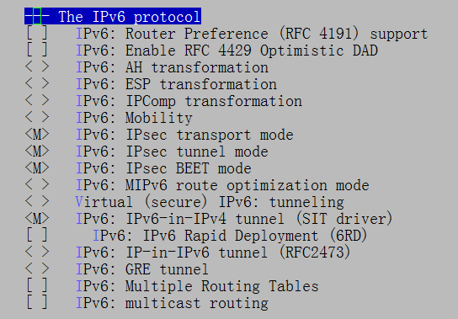

The IPv6 configurations are as follows:
- Configure the IP address and the default gateway by running the following command:
ip -6 addr add <ipv6address>/<ipv6_prefixlen> dev <port>
Example: ip -6 addr add 2001:da8:207::9402/64 dev eth0
- Ping a website by running the following command:
ping -6 <ipv6address>
Example: ping -6 2001:da8:207::9403

Configuring the PHY Address
- Configuring the PHY address under the U-Boot.
To configure the PHY address under the U-Boot, change the value of the HISFV_PHY_U macro definition in the configuration files of U-Boot. The U-Boot configuration file of Hi3516C V500 is as follows:
include/configs/hi3516cv500.h
- Configuring the PHY address under the kernel.
The PHY address can be configured under the kernel by modifying the DTS configuration file hi3516cv500-demb.dts in the arch/arm/boot/dts directory. As shown in Figure 1-2, the value 1 in "reg = <1>" indicates the PHY address.
              - PHY address configuration node
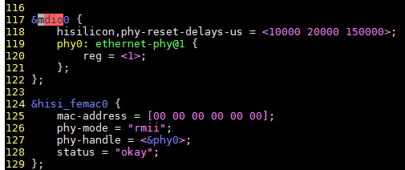

IEEE 802.3x Flow Control Configuration

Flow Control Function
The ETH network supports the flow control function defined in IEEE 802.3x. It can transmit pause frames to and receive and process pause frames from the peer end.
- Transmitting pause frames:
In the RX direction, if the current RX descriptor queue is insufficient, some received data packets may not be sent to the software. In this case, a pause frame is sent to the peer end to inform the peer end that no packet will be sent during a certain period.
- Receiving pause frames:
When a pause frame is received, the ETH performs delay transmission according to the flow control time field in the frame. After the flow control time is up, the ETH sends the pause frame again or receives the pause frame whose flow control time is 0 from the peer end, the sending is also started again.

Flow Control Configuration
The function of receiving pause frames is enabled by default and cannot be disabled. Therefore, the software interface configuration is not provided.
You can modify the configuration related to the function of sending pause frames in driver/net/ethernet/hisilicon/hisi_femac/hisi_femac.c. The configuration of the network driver is modified as follows:
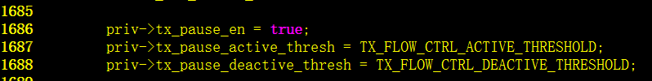

The flow control parameters that can be configured are as follows:
- priv->tx_pause_en
Whether the function of transmitting pause frames is enabled
- priv->tx_pause_active_thresh
Threshold for activating the function of transmitting pause frames. When the number of available descriptors in the RX queue is less than this value, the logic of the process for transmitting pause frames is enabled.
- priv->tx_pause_deactive_thresh
Threshold for deactivating the function of transmitting pause frames. When the number of available descriptors in the RX queue is greater than or equal to this value and the RX queue is in the flow control status, the current flow control status is deactivated.
The threshold for activating the flow control function must be smaller than the threshold for deactivating the flow control function.

ethtool Configuration Interface
You can enable the flow control function through the standard ethtool interface.
Run the ethtool –a eth0 command to check the flow control status of the eth0 port. The following information is displayed:
# ./ethtool -a eth0
Pause parameters for eth0:
Autonegotiate: on
RX: on
TX: on
RX flow control is enabled, and TX flow control is also enabled.
You can run the following commands to enable or disable the TX flow control function:
# ./ethtool -A eth0 tx off (Disable TX flow control.)
# ./ethtool -A eth0 tx on (Enable TX flow control.)
RX flow control is enabled by default and cannot be disabled. Therefore, RX flow control cannot be configured using the ethtool.

Operation Guide to the USB Module
- For Hi3516C V500, the USB 2.0 DRD (dual role device) module supports the USB 2.0 host mode and USB 2.0 device mode.
- For Hi3516C V500, the USB 2.0 DRD module can be used only in the USB 2.0 host mode or USB 2.0 device mode.

Preparations
Before using the USB DRD, ensure that the following items are available:
- U-Boot and Linux kernel released in the SDK
- NFS or the local file system Yaffs2, JFFS2, ext4 or Cramfs (JFFS2 is recommended)

Procedure

USB Host Operation Procedure Under U-Boot
Currently, U-Boot supports only storage devices, such as the USB flash drive and hard disk. A device with a CD-ROM partition is not supported. Insert the device to the PC and check the drive letter of the device. If the CD-ROM drive letter is displayed, it indicates that the device has a CD-ROM partition.
Compile the USB drivers under U-Boot.
- Select the driver configurations in menuconfig as follows. All options are selected by default.
Command line interface --->
Device access commands --->
[*] usb
Device Drivers --->
[*] Hisi usb phy driver
[*] USB support --->
[*] xHCI HCD (USB 3.0) support
[*] USB Mass Storage support
              - Options of the U-Boot drivers
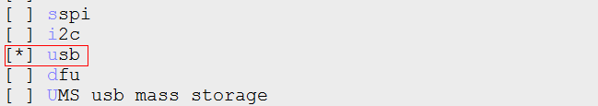
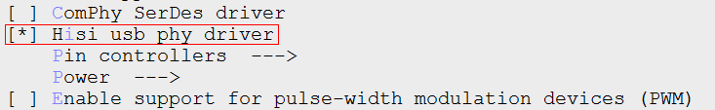
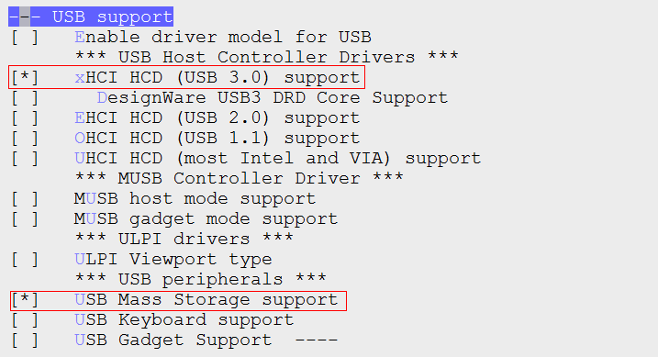

- Compile the following commands:
make ARCH=arm CROSS_COMPILE=arm-himix200-linux- hi3516cv500_defconfig
make ARCH=arm CROSS_COMPILE=arm-himix200-linux- -j 20
cp ../../../tools/pc/uboot_tools/reg_info.bin .reg
make ARCH=arm CROSS_COMPILE=arm-himix200-linux- u-boot-z.bin
The generated u-boot-hi3516cv500.bin file is the available U-Boot image.

USB Host Operation Procedure Under Kernel
The operation procedure is as follows:
          - Start the board, and load the NFS or the file system Yaffs2, JFFS2, ext4 or Cramfs.
          - Insert a USB host device such as the USB flash drive, mouse, or keyboard, and then perform operations on the USB device. For details, see section 1.2.3 "Operation Instances."
The drivers related to the USB host are as follows:
- Drivers related to the file system and storage devices
- Vfat
- ext4
- scsi_mod
- sd_mod
- nls_ascii
- nls_iso8859-1
- Drivers related to the keyboard
- evdev
- usbhid
- Drivers related to the mouse
- mousedev
- usbhid
- evdev
- Drivers related to the USB host
- xhci-hcd
- xhci-plat-hcd
- usb-storage
- phy-hisi-usb
----End

USB Device Operation Procedure Under Kernel

Using the USB Device
          - Compile the kernel drivers related to the USB device.
- Run make ARCH=arm CROSS_COMPILE=arm-hisiv200-linux- menuconfig to enter the menuconfig menu. When the USB device is used as a virtual USB flash drive, compound device, or camera, the configuration is as follows:
Device Drivers --->
[*] USB support --->
<*> DesignWare USB3 DRD Core Support
DWC3 Mode Selection (Gadget only mode) --->
<*> USB Gadget Support --->
<M> USB functions configurable through configfs
[*] USB Webcam function
<M> USB Gadget Drivers
< > Ethernet Gadget (with CDC Ethernet support)
<M> Mass Storage Gadget
< > Serial Gadget (with CDC ACM and CDC OBEX support)
<M> Multifunction Composite Gadget
[*] RNDIS + CDC Serial + Storage configuration (NEW)
PHY Subsystem --->
<*> HISI USB2 PHY Driver
[*] Hisilicon USB related configuration --->
[*] USB DRD0 Mode Select HOST
[ ] USB DRD0 Mode Select DEVICE
File systems --->
Pseudo filesystems --->
{*} Userspace-driven configuration filesystem
For DRD0, USB DRD0 Mode Select HOST and USB DRD0 Mode Select DEVICE are exclusive. If they are both selected, the device mode is used by default.
              - Major options of the kernel module
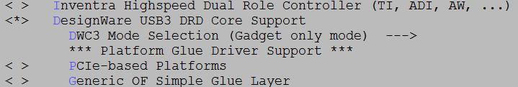
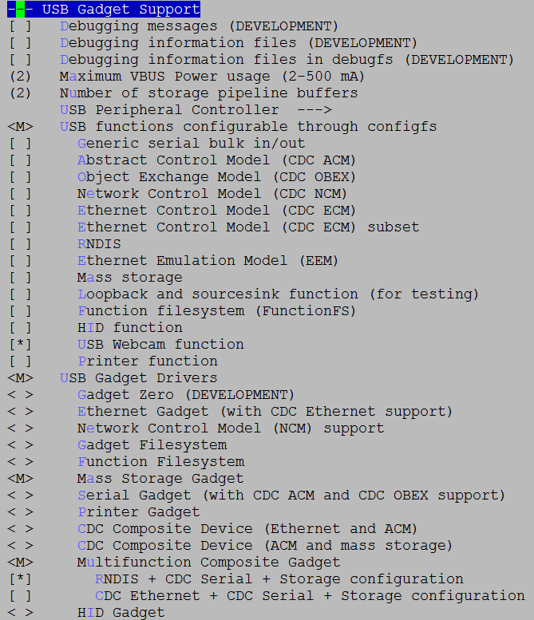
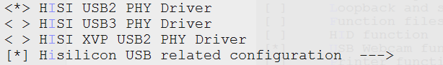
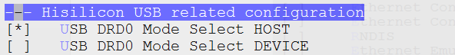
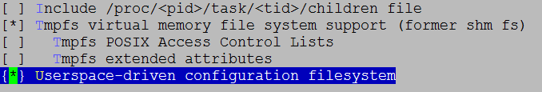

- Compile the kernel drivers to generate .ko files.
make ARCH=arm CROSS_COMPILE=arm-himix200-linux- modules
Note: Before compiling the module, compile the kernel first by running the following command:
make ARCH=arm CROSS_COMPILE=arm-himix200-linux- uImage
          - Start the board, and load the NFS or the file system Yaffs2, JFFS2, ext4, or Cramfs.
          - Load the device drivers when the board acts as a device. In this way, the board can be identified by the host as the corresponding USB device. For details, see section 1.2.3 "Operation Instances."
The drivers related to the USB 2.0 device are as follows:
- Drivers related to the file system and storage devices, which are the same as those of the host
- USB device module
- Drivers related to the USB virtual USB flash drive
libcomposite.ko
usb_f_mass_storage.ko
g_mass_storage.ko
- Drivers related to the USB composite device
libcomposite.ko
u_ether.ko
u_serial.ko
usb_f_acm.ko
usb_f_rndis.ko
g_multi.ko
- Drivers related to the USB camera
libcomposite.ko
usb_f_uvc.ko
----End

Operation Instances

Instance of Using the USB Flash Drive Under U-Boot

Inserting the Device Before Power-on
U-Boot does not support hot swap. Before powering on the system, insert the device into the USB port.
Power on the board, enter the U-Boot CLI, run the usb start command, and check whether the device is successfully detected.
- Generally, when a Hi-Speed or SuperSpeed USB flash drive is inserted into the USB port, the following information is displayed on the serial port:
hisilicon # usb start
USB0: Register 1000140 NbrPorts 1
Starting the controller
USB XHCI 1.10
scanning bus 0 for devices... 2 USB Device(s) found
scanning usb for storage devices... 1 Storage Device(s) found
After usb start is executed, if an enumeration error (such as Device not responding to set address) is reported or the device cannot be detected, run the following command in the U-Boot CLI: setenv usb_pgood_delay XXX. This setting applies to devices that requires longer preheating period to increase the timeout period for waiting for device power-on. XXX can be set to a proper value based on the preheating speed of the device. The recommended value range is 1000–3000.
After the identification is complete, run the usb tree command to check the identification rate.
- Generally, when a Hi-Speed or SuperSpeed USB flash drive is inserted into the USB port, the following information is displayed on the serial port:
hisilicon # usb tree
USB device tree:
1 Hub (5 Gb/s, 0mA)
| U-Boot XHCI Host Controller
|
+-2 Mass Storage (480 Mb/s, 250mA)
Generic Mass Storage Device 121220130416

Initialization and Application
After the identification is complete, perform the following operations:
          - View the device information.
- Run the usb info [dev] command in the U-Boot CLI to view the information about all devices connected to the controller. You can add parameters to the command to view the information about a specific device, for example, usb info 2. The following shows an example:
hisilicon # usb info 2
config for device 2
2: Mass Storage, USB Revision 2.0
- Generic Mass Storage B92AAF26
- Class: (from Interface) Mass Storage
- PacketSize: 64 Configurations: 1
- Vendor: 0x058f Product 0x6387 Version 1.0
Configuration: 1
- Interfaces: 1 Bus Powered 200mA
Interface: 0
- Alternate Setting 0, Endpoints: 2
- Class Mass Storage, Transp. SCSI, Bulk only
- Endpoint 1 Out Bulk MaxPacket 512
- Endpoint 2 In Bulk MaxPacket 512
          - Read the USB flash drive.
- Run the usb read addr blk# cnt command in the U-Boot CLI to read the data whose blk size of the start address is cnt to the DDR addr. The following shows an example of successful read:
hisilicon # usb read 0x82000000 0 2000
USB read: device 0 block # 0, count 8192 ... 8192 blocks read: OK
          - Write data to the USB flash drive.
- Run the usb write addr blk# cnt command in the U-Boot CLI to write the data of the cnt size of the DDR addr to the blk position of the USB flash drive. The following shows an example of successful write:
hisilicon # usb write 0x82000000 2000 2000
USB write: device 0 block # 8192, count 8192 ... 8192 blocks write: OK
----End

Instance of Using the USB Flash Drive Under Kernel

Inserting and Detecting a USB Flash Drive
Insert a USB flash drive, and then check whether it can be detected.
- If a high-speed USB flash drive is inserted to the USB 2.0 host, the following information is displayed over the serial port in normal cases:
~ # usb 1-1: new high-speed USB device number 2 using xhci-hcd
scsi2 : usb-storage 1-1:1.0
scsi 2:0:0:0: Direct-Access Kingston DT 101 G2 1.00 PQ: 0 ANSI: 4
sd 2:0:0:0: [sda] 15131636 512-byte logical blocks: (7.74 GB/7.21 GiB)
sd 2:0:0:0: [sda] Write Protect is off
sd 2:0:0:0: [sda] Write cache: disabled, read cache: enabled, does not support DPO or FUA
sda: sda1
sd 2:0:0:0: [sda] Attached SCSI removable disk
- If a super-speed USB flash drive is inserted to the USB 2.0 host, the following information is displayed over the serial port in normal cases:
~ # usb 1-1: new high-speed USB device number 3 using xhci-hcd
scsi2 : usb-storage 1-1:1.0
scsi 2:0:0:0: Direct-Access Kingston DT 101 G2 1.00 PQ: 0 ANSI: 4
sd 2:0:0:0: [sda] 15131636 512-byte logical blocks: (7.74 GB/7.21 GiB)
sd 2:0:0:0: [sda] Write Protect is off
sd 2:0:0:0: [sda] Write cache: disabled, read cache: enabled, doesn't support DPO or FUA
sda: sda1
sd 2:0:0:0: [sda] Attached SCSI removable disk
Where, sda1 is the first partition of the USB flash drive or the portable drive. If there are multiple partitions, information such as sda1, sda2, sda3, …, and sdaN is displayed.

Using the USB Flash Drive
Perform the following initialization steps after the related drivers are loaded:
In sdXY, X indicates the disk ID, and Y indicates the partition ID. You need to change them as required.
- The sdX device node is partitioned by running the partition command such as $ fdisk /dev/sda.
- The sdXY partition is formatted by running the mkdosfs command such as ~ $ mkdosfs –F 32 /dev/sda1.
- The sdXY partition is mounted by running the mount command such as ~ $ mount -t vfat /dev/sda1 /mnt.
          - Check whether the USB flash drive is partitioned.
- Run ls /dev to view system device files. If sdXY is not displayed, the USB flash drive is not partitioned. In this case, run the ~ $ fdisk /dev/sda command to partition it. For details, see section 1.7.1 "Partitioning a Storage Device.", and then go to Step 11.
- If sdXY is displayed, the USB flash drive is detected and partitioned. In this case, go to Step 11.
          - Check whether the USB flash drive is formatted.
- If it is not formatted, run the ~ $ mkdosfs –F 32 /dev/sdaX command to format it. For details, see section 1.7.2 "Formatting a Partition."
- If it is formatted, go to Step 12.
          - Check whether a directory is mounted.
- If no directory is mounted, run the ~ $ mount -t vfat /dev/sdaX /mnt command to mount a directory. For details, see section 1.7.3 "Mounting a Directory."
- If a directory is mounted, go to Step 13.
          - Read/write to the USB flash drive. For details, see section 1.7.4 "Reading/Writing to a File."
----End

Using the Keyboard Under Kernel
Before you can use the keyboard, you need to perform the following steps:
          - Load the drivers related to the keyboard.
After the drivers related to the keyboard are loaded, the event0 node is generated in /dev/input.
          - Receive the keyboard inputs by running the following command:
cat/dev/input/event0
          - Press any keys on the keyboard.
If no error occurs, the content that you entered is displayed on the screen.
----End

Using the Mouse Under Kernel
Before you can use the mouse, perform the following steps:
          - Load the drivers related to the mouse.
After the drivers related to the mouse are loaded, the mouse0 node is generated in /dev/input.
          - Receive the mouse inputs by running the following command:
cat/dev/input/mouse0
          - Click randomly on the screen or move the pointer.
If the mouse functions properly, the corresponding code value is displayed.
----End

Using the Storage Media of the USB Device Under Kernel
When the board serves as a virtual USB flash drive, perform the following steps (the flash memory and SD card are used as storage media.):
          - Load the drivers related to the USB device.
- When the flash memory is used as the storage medium of the virtual USB flash drive, run the following commands:
insmod libcomposite.ko
insmod usb_f_mass_storage.ko
insmod g_mass_storage.ko file=/dev/mtdblockX luns=1 stall=0 removable=1
The mtdblockX partition is partition X of the Flash. You can select the partition as required.
- When the SD card is used as the storage medium of the virtual USB flash drive, run the following commands:
insmod libcomposite.ko
insmod usb_f_mass_storage.ko
insmod g_mass_storage.ko file=/dev/mmcblk0pX luns=1 stall=0 removable=1
The mmcblk0pX partition is partition X of the SD card. You can select the partition as required.
Drivers for configuring the virtual USB flash drive are stored in the following paths in the kernel:
- drivers/usb/gadget/libcomposite.ko
- drivers/usb/gadget/function/usb_f_mass_storage.ko
- drivers/usb/gadget/legacy/g_mass_storage.ko
          - Connect the board to the PC over a USB port. The PC can identify the drive letter. In this situation, the board equals a USB flash drive.
----End

Using the Composite Device Function of the USB Device Under Kernel
When the board serves as a composite device, perform the following steps:
          - Download libcomposite.ko, u_ether.ko, u_serial.ko, usb_f_acm.ko, usb_f_rndis.ko, and g_multi.ko on the board to the /root/ directory.
          - Run vi/etc/init.d/rcS to adding the following commands to the file, and then save and exit the file.
cd /root/
insmod libcomposite.ko
insmod u_ether.ko
insmod u_serial.ko
insmod usb_f_acm.ko
insmod usb_f_rndis.ko
insmod g_multi.ko
Drivers for configuring the compound device are stored in the following paths in the kernel:
- drivers/usb/gadget/libcomposite.ko
- drivers/usb/gadget/function/u_ether.ko
- drivers/usb/gadget/function/u_serial.ko
- drivers/usb/gadget/function/usb_f_acm.ko
- drivers/usb/gadget/function/usb_f_rndis.ko
- drivers/usb/gadget/legacy/g_multi.ko
          - Run the following commands on the board.
vi /etc/inittab
#::respawn:/sbin/getty -L ttyS000 115200 vt100 -n root -I "Auto login as root ..."
::respawn:/sbin/getty -L ttyGS0 115200 vt100 -n root -I "Auto login as root ..."
          - If the host is a PC, add the linux-cdc-acm.inf and linux.inf files in 01.software\pc\usb_tools to the PC.
          - Connect the board to the host by using the USB cable. The PC can automatically load the drivers, but generally the loading operation fails. In this case, install the driver as follows:
            - Right-click the Computer icon on the desktop and select Management from the shortcut menu.
            - Open the Device Manager window.
            - Click the port (COM and LPT), and double-click Gadget Serial(COMx).
            - Click Network adapters, and double-click Linux USB Ethernet /RNDIS Gadget #x.
            - In the displayed window, click the Driver tab. On the Driver tab page, click Update Driver… and then Browse my computer for driver software.
            - In the displayed window, click Browse and select the directory 01.software\pc\usb_tools where linux-cdc-acm.inf and linux.inf are located, and click Next. The PC will automatically install the driver program. After the driver program is successfully installed, close the GUI.
          - Configure the IP address on the board by running ifconfig usb0 xx.xx.xx.xx netmask 255.255.xxx.0; route add default gw xx.xx.xx.xx.
          - When the board and the PC are connected through a USB data cable, the USB network port is generated on the PC. Choose Start > Control Panel, click Network and Sharing Center, and then choose Change adapter settings > Linux USB Ethernet /RNDIS Gadget #x.
          - Build the bridge.
            - Right-click Linux USB Ethernet /RNDIS Gadget #x and choose Add to Bridge.
            - Right-click the local connection node on the PC for connecting to the extranet and choose Add to Bridge.
            - Wait until the bridge is established, as shown in Figure 1-1.
              - Successfully building the bridge
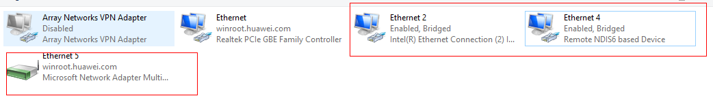

          - Access the network from the board. If you need to use the serial port, restart the board and open the USB serial port in the device manager. In this situation, the USB port equals the network port and serial port. The function configuration for the composite device is complete.
----End

Using the USB Camera (UVC) Under Kernel
                - Resolutions supported by the USB camera (UVC)
Transfer Mode | Stream Format | Resolution
Isochronous | YUY2 | 640 x 360
Isochronous | MJPEG | 640 x 360, 1280 x 720, and 1920 x 1080
Isochronous | H264 | 640 x 360, 1280 x 720, and 1920 x 1080

When the board serves as a camera, perform the following steps:
The directories of the modules in the kernel are as follows when the USB device functions as a camera:
- drivers/usb/gadget/libcomposite.ko
- drivers/usb/gadget/function/usb_f_uvc.ko
          - Compile the application program uvc_app.
For details, see the readme.txt in the {SDK_PATH}/mpp/sample/uvc_app directory.
          - On the board, download libcomposite.ko, usb_f_uvc.ko, uvc_app, and media driver directories to the /root/ directory.
          - Run vi /etc/init.d/rcS to add the following commands to the file, and then exit after saving the commands.
cd /root/
insmod libcomposite.ko
insmod usb_f_uvc.ko
export VID="0x12d1"
export PID="0x4321"
export MANUFACTURER="Huawei"
export PRODUCT="HiCamera"
export SERIALNUMBER="12345678"
export CamControl1=0xa
export CamControl2=0x0
export CamControl3=0x0
export ProcControl1=0x4f
export ProcControl2=0x14
export YUV="360p"
export MJPEG="360p 720p 1080p"
export H264="360p 720p 1080p "
./ConfigUVC.sh
cd /root/ko
./load3516dv300 -a -sensor0 imx335
cd /root/
./uvc_app &
- If the driver has been compiled to the kernel, you do not need to perform the insmod ko operation.
- Drivers for configuring the camera are stored in the following paths in the kernel:
- drivers/usb/gadget/dwc3.ko
- drivers/usb/gadget/libcomposite.ko
- drivers/usb/gadget/function/usb_f_uvc.ko
- Variables modified by export are configurable. The meanings of the variables are as follows:
- VID indicates the vendor ID.
- PID indicates the product ID.
- MANUFACTURER indicates the vendor name.
- PRODUCT indicates the product name.
- SERIALNUMBER indicates the product serial number.
- CamControl1, CamControl2, and CamControl3 indicate the camera control functions defined by the protocol. For details about the meaning of each bit, see the UVC protocol. The default value is the maximum value of the supported function.
- ProcControl1 and ProcControl2 indicate the processing control functions defined by the protocol. For details about the meaning of each bit, see the UVC protocol. The default value is the maximum value of the supported function.
- YUV, MJPEG, and H264 indicate the resolutions supported by each format. For example, H264="360p 720p 1080p" indicates that the H.264 format supports three resolutions (640 x 360, 1280 x 720, and 1920 x 1080). To remove a resolution, for example 640 x 360, you can modify the H.264 variable value as H264="720p 1080p". Each format supports at least one resolution. By default, all supported resolutions are configured.
- The ConfigUVC.sh script provided as follows is necessary for starting the UVC. You do not need to modify it.

- The /root/ko directory contains the media drivers.
- Save the configuration file uvc_app.conf in the same directory as the uvc_app file.
          - Connect the board to the PC terminal using a USB cable. After the board is identified by the PC terminal, UVC Camera is displayed in the device list, as shown in Figure 1-1.
              - UVC node in Device Manager
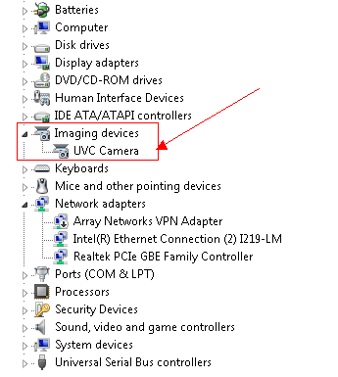

          - Use the PotPlayer software on the PC to capture audio and video. You can download the software from the following official website. For a 32-bit PC, download 32-bit PotPlayer. For a 64-bit PC, download 64-bit PotPlayer.
https://daumpotplayer.com/download/
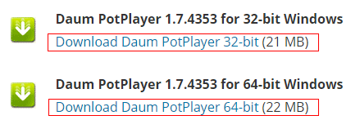

AMcap is developed based on the Windows DirectShow technology. It uses the DTV-DVD H.264 decoder provided by Windows to decode H.264 streams, causing H.264 decoding suspension or artifacts. Therefore, AMcap or other software is not recommended.
          - Install the PotPlayer software. During the installation, select the Detect H/W decoder/encoder option (it is deselected by default) and retain the default settings for other steps, as shown in Figure 1-1.
              - Installation process
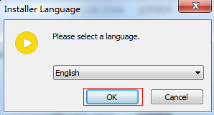
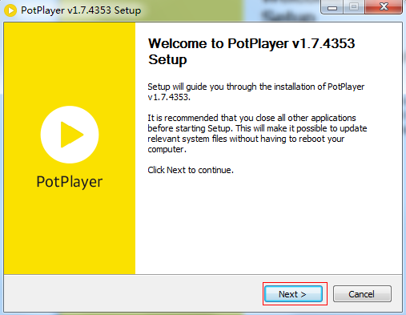
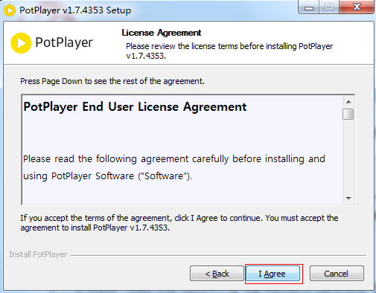
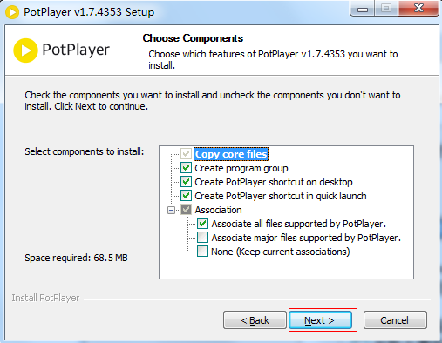
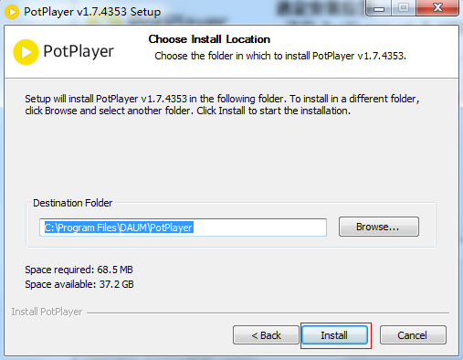
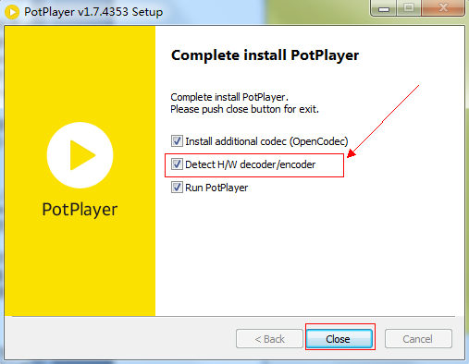

Then, the installation is complete.
          - Use PotPlayer on PC to collect data.
Verify the camera functions. The normal video output on the PC indicates that the video paths of the camera are normal. The detailed operations are as follows:
            - Choose PotPlayer > Preferences… from the main menu, as shown in Figure 1-1.
              - PotPlayer main menu
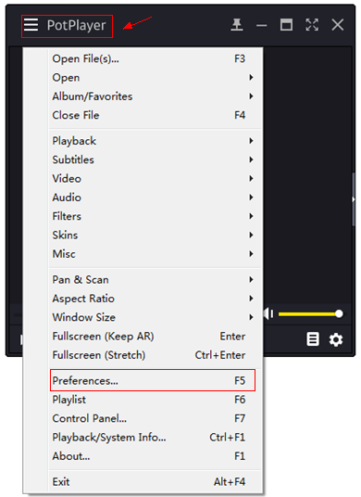

            - Choose Device > Webcam. Verify that the video recording device is UVC camera and select a format. Then click OK. Choose Open > Open Webcam/Other Device, as shown in Figure 1-1, and you can view the video output.
              - Preferences dialog box
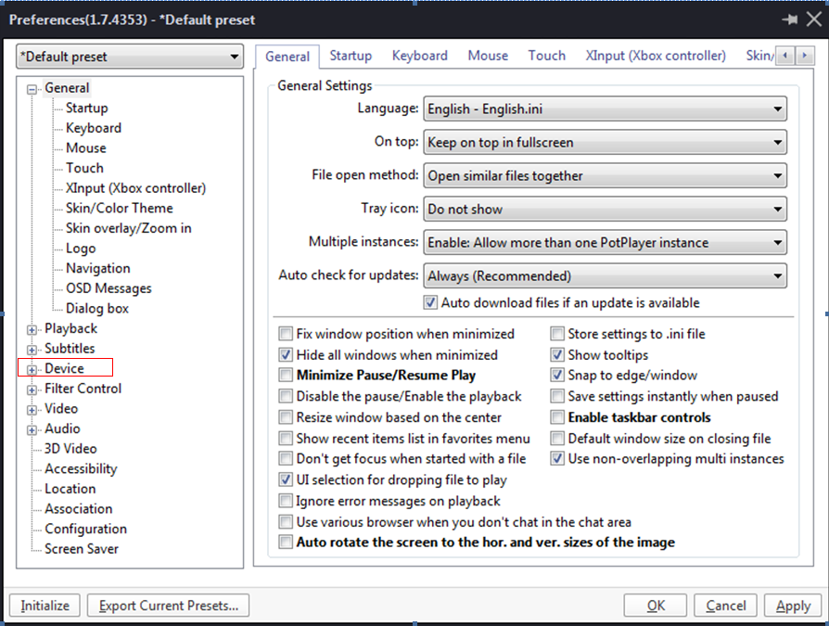
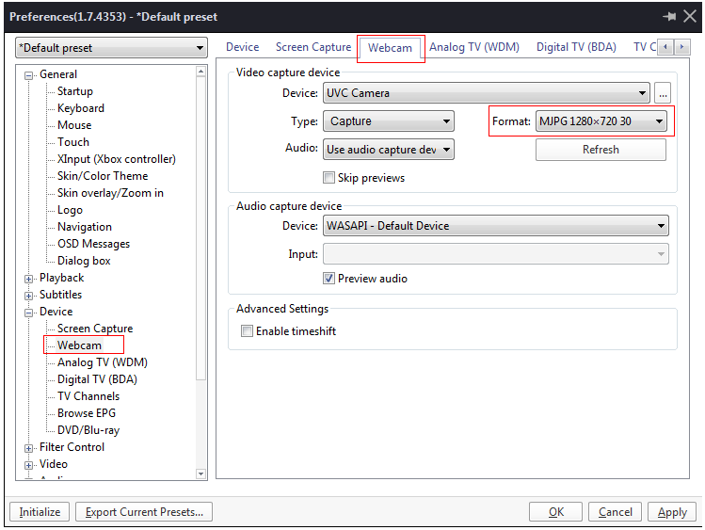
              - PotPlayer main menu
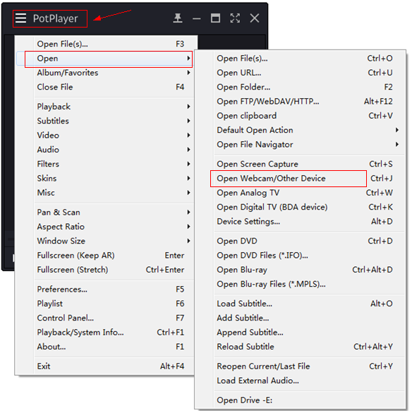

----End

Precautions
Note the following when performing the operations related to the USB 3.0 module:
- You need to run the mount command, operate a file, and then run the umount command in sequence each time. This avoids exceptions in the file system.
- The drivers of the keyboard and mouse must work with the upper layer. For example, mouse events are displayed on the graphical user interface (GUI) of the upper layer. You only need to operate the keyboard by accessing the event node in /dev. However, standard libraries are required for mouse operations.
- Mouse application libgpm libraries are provided in Linux. If you need to use the mouse, these libraries must be compiled. You are recommended to use the standard kernel interface gpm-1.20.5 that has passed the test.
In addition, a set of test programs (such as mev) is provided in the gpm tool. You can perform encoding by using the test programs, making the development easier.
The drivers related to the USB device must be loaded before the board is connected to the host. Otherwise the host cannot identify the USB device, and the misoperation information is displayed repeatedly.
- When the USB 3.0 functions as the USB device network port, delete the preceding bridge and create another bridge every time when the board is restarted.

Operation Guide to the SD Card /MMC/eMMC

Preparations
Before using the SD card, MMC, or eMMC, ensure that the following items are available:
- The U-Boot and Linux use the U-Boot and kernel released by the SDK
- File systems
You can use the local file system Yaffs2, JFFS2, ext4, or SquashFS released in the SDK or mounted to the NFS.

Procedure
To use the SD card or MMC, perform the following steps:
          - Start the board, and load the local file system Yaffs2, JFFS2, ext4, or SquashFS or mount the local file system to the NFS.
          - Load the kernel. By default, all drivers related to the SD card, MMC, or eMMC are compiled in the kernel. Therefore, you do not need to load the drivers. The drivers related to the SD card, MMC, or eMMC are as follows:
- Drivers related to the file system and storage devices
- nls_base
- nls_cp437
- fat
- vfat
- msdos
- nls_iso8859-1
- nls_ascii
- SD, MMC, or eMMC drivers
- mmc_core
- himci
- mmc_block
          - Insert the SD card, MMC, or eMMC. Then you can perform operations on the SD card, MMC, or eMMC. For details, see section 1.3.3 "Operation Instances."
----End

Operation Instances
The following instance describes how to read/write to an SD card by using the SDIO interface. The procedure for reading/writing to an MMC or eMMC is similar to that for reading/writing to an SD card, and therefore is not described in this document. Note that the eMMC does not support hot plug. Figure 1-1shows the read/write flowchart.
              - Read/write flowchart
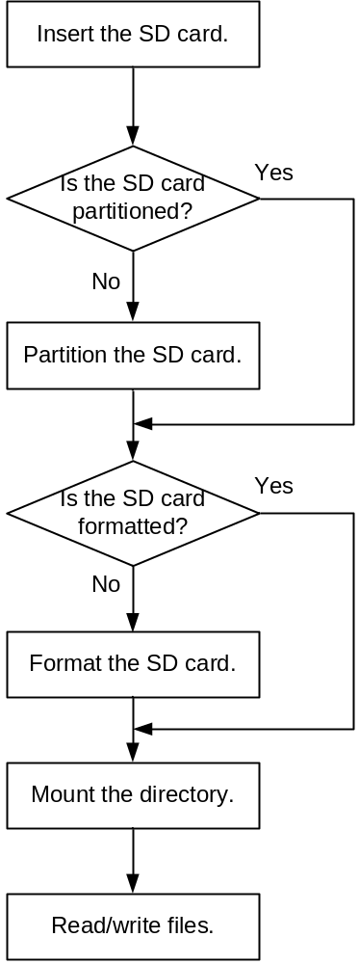

After initialization and application, and the SD card, MMC, or eMMC is inserted, perform the following steps:
In the following commands, X indicates the partition number that is assigned when you partition an SD card or MMC by running the fdisk command.
- The directory in which the fdisk command is executed must be changed to ~ $ fdisk /dev/mmcblk0.
- The directory formatted by running the mkdosfs command must be changed to ~ $ mkdosfs –F 32 /dev/mmcblk0pX.
- The mount directory must be changed to ~ $ mount -t vfat /dev/mmcblk0pX /mnt.
          - Check whether the SD card or MMC is partitioned.
- If p1 is not displayed, the SD card or MMC is not partitioned. In this case, run the ~ $ fdisk /dev/mmcblk0 command to partition the SD card or MMC. For details, see section 4.1.
- If p1 is displayed, the SD card or MMC is detected and partitioned. In this case, go to Step 2.
          - Check whether the SD card or MMC is formatted.
- If the SD card or MMC is not formatted, format it by following section 1.7.2 "Formatting a Partition."
- If it is formatted, go to Step 3.
          - Mount the directory by following section 1.7.3 "Mounting a Directory."
          - Read/write to the SD card, MMC, or eMMC. For details, see section 1.7.4 "Reading/Writing to a File."
----End

Precautions During Operations
Note the following during operation:
- Ensure that the metal sheet of the card is in good contact with the card slot; otherwise, the card fails to be detected or an error occurs in reading/writing to the card. When testing a thin MMC, hold the communication end of the slot if necessary.
- Before reading data from or writing data to the SD card, ensure that the SD card is partitioned and formatted to the vfat file system by running the fdisk and mkdosfs commands. For details, see 1.3.3 "Operation Instances."
- You need to run the mount command to mount an SD card to a file system so that you can read/write to the SD card. After you remove an SD card, you need to release the mount node by running the umount command; otherwise, the partitions of the SD card fail to be detected after the card is inserted again.
- If an SD card is removed, you need to release the mount node by running the umount command. You are advised to run the umount command, and remove the SD card in sequence. If an SD card is removed incorrectly, you also need to release the mount node by running the umount command; otherwise, the partitions of the SD card fail to be detected after it is inserted again.
Do not perform the following operations:
- Do not remove an SD card during read/write. Otherwise, exception information is displayed, and the files in the SD card or the file system may be damaged.
- When the current directory is the mount directory such as /mnt, the mount node cannot be released.
- If the process of reading or writing the mount directory in the system does not end, do not run the umount command. Wait till the process ends.
Take the following measures if exceptions occur during operation:
- If a card is removed incorrectly during a cyclic test, press Ctrl+C to roll back to the shell; otherwise, misoperation information is displayed repeatedly
- If you reseat a card rapidly, the card may fail to be detected. This is because the registration and deregistration processes take a period of time.
- If a card is removed incorrectly, run the umount command to release the mount node. Otherwise, the mount node directory, /mnt for example, cannot be read or written and misoperation information is displayed.
- If an SD card has multiple partitions, you can run the mount command to switch to another partition for mounting. Ensure that the times of running the umount command are the same as those of running the mount command. In this way, all mounted partitions can be released.
- If the file system is damaged due to read/write operations or other exceptions, the file system may be panic after you reseat the card, mount a folder, and then read/write to the card. In this case, run the umount command, reseat the SD card, and then run the mount command.

Operation Guide to the I²C

Preparations
Before using the I²C, ensure that the following items are available:
- Linux kernel released in the SDK
- File systems
You can use the local file system Yaffs2, JFFS2, ext4, or SquashFS released in the SDK or mounted to the NFS.

Procedure
To use the I²C, perform the following steps:
          - Start the board, and load the local file system Yaffs2, JFFS2, ext4, or SquashFS or mount the local file system to the NFS.
          - Load the kernel. By default, all drivers related to the I²C module are compiled in the kernel. Therefore, you do not need to load the drivers.
          - Run I²C read and write commands on the console or compile I²C read and write programs in kernel mode or user mode to read/write to the peripherals mounted on the I²C controller. For details, see section 1.4.4 "Operation Instances."
----End

Interface Rate Configuration
The default interface rate is 100 kbit/s in the SDK. To change the interface rate, you need to modify arch/arm/boot/dts/hi3516cv500.dtsi and recompile the kernel as follows:
Change the value of the clock-frequency attribute in the node i2c_bus0, as shown in Figure 1-1.
              - Configuring the interface rate
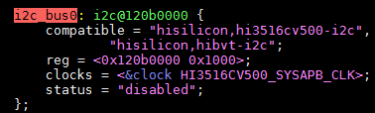

Operation Instances

I²C Read and Write Commands
The following instances describe how to read and write to I²C peripherals by running I²C read and write commands:
- To read I²C peripherals on the console, run i2c_read:
~ $ i2c_read <i2c_num> <device_addr> <reg_addr> <end_reg_addr> <reg_width> <data_width> <reg_step>
- For example, to read the register (address: 0x8) of the device (address: 0x72) mounted on I²C controller 0, run the following command:
~ $ i2c_read 0 0x72 0x8 0x8 0x1 0x1
- i2c_num: I²C controller ID (corresponding to the I²C controller ID in the Hi3516C V500 Professional Smart IP Camera SoC Data Sheet)
- device_addr: peripheral address (The Hi3516C V500 supports the 7-bit standard address and 10-bit extended address.)
- reg_addr: start address for reading peripheral registers
- end_reg_addr: end address for reading peripheral registers
- reg_width: bit width of peripheral registers (The Hi3516C V500 supports 8-bit, 16-bit, 24-bit, or 32-bit width.)
- data_width: data width of peripherals (The Hi3516C V500 supports 8-bit, 16-bit, 24-bit, or 32-bit data width.)
- reg_step: incremental step when peripheral registers are read consecutively. The default value is 1, indicating that two or more registers are read consecutively. This parameter is not used when only one register is read.
- To write to I²C peripherals on the console, run i2c_write:
~ $ i2c_write <i2c_num> <device_addr> <reg_addr> <value> <reg_width> <data_width>
For example, to write 0xa5 to the register (address: 0x8) of the device (address: 0x72) mounted on I²C controller 0, run the following command:
~ $ i2c_write 0 0x72 0x8 0xa5 0x1 0x1
- i2c_num: I²C controller ID (corresponding to the I²C controller ID in the Hi3516C V500 Professional Smart IP Camera SoC Data Sheet
- device_addr: peripheral address (The Hi3516C V500 supports the 7-bit standard address and 10-bit extended address.)
- reg_addr: address for writing to peripheral registers
- value: data written to peripheral registers
- reg_width: bit width of peripherals (The I²C controller of the Hi3516C V500 supports 8-bit, 16-bit, 24-bit, or 32-bit width.)
- data_width: data bit width of peripherals (The I²C controller of the Hi3516C V500 supports 8-bit, 16-bit, 24-bit, or 32-bit width.)

I²C Read and Write Programs in Kernel Mode
The following instance describes how to read/write to I²C peripherals by compiling I²C read and write programs in kernel mode:
          - Call functions at the I²C core layer. i2c_adap is obtained, which is a structure of the I²C controller.
i2c_adap = i2c_get_adapter(0);
Assume that the new peripheral is mounted on I²C controller 0, the parameter value of i2c_get_adapter can be set to 0.
          - Associate the I²C controller with the new I²C peripheral. hi_client is obtained, which is a data structure that describes the client of I²C peripherals.
hi_client = i2c_new_device(i2c_adap, &hi_info);
The hi_info structure provides the address of the I²C peripheral.
          - In a non-interrupt context, call the standard read and write functions provided by the I²C core layer to read/write to peripherals.
ret = i2c_master_send(client, buf, count);
ret = i2c_transfer(client->adapter, msg, 2);
In an interrupt context, call the read and write functions provided by the I²C driver layer to read/write the peripherals.
ret = hi_i2c_master_send(client, buf, count);
ret = hi_i2c_transfer (client->adapter, msg, 2);
- The client parameter is the hi_client structure obtained in step 2, which is a data structure that describes the client of I²C peripherals.
- The buf parameter is the register or data needs to be read or written.
- The count parameter is the length of buf.
- The msg parameter is the initial address of two i2c_msg during the read operation.
The code instance is as follows:
The following code instance is a sample program, which only serves as a reference for customers when they develop kernel-mode I²C peripheral drivers. The code has no actual functions.
//Information list for I²C peripherals
static struct i2c_board_info hi_info = {
//Each I2C_BOARD_INFO structure represents a supported I²C peripheral. The device name is hi_test and the device address is 0x72.
I2C_BOARD_INFO("hi_test", 0x39),
};
When the code is called, the read and write bits cannot be included in the device address, but need to be included in the command line.
static struct i2c_client *hi_client = NULL;

int hi_i2c_write(unsigned int reg_addr, unsigned int reg_addr_num,
unsigned int data, unsigned int data_byte_num)
{
unsigned char buf[8];
int ret = 0;
int idx = 0;
struct i2c_client *client;

client = hi_client;

/* reg_addr config */
if (reg_addr_num == 2)
buf[idx++] = (reg_addr >> 8);
buf[idx++] = reg_addr;

/* data config */
if (data_byte_num == 2)
buf[idx++] = data >> 8;
buf[idx++] = data;
//In a non-interrupt context, call the I²C standard write function provided by the kernel to perform the write operation.
ret = i2c_master_send(client, buf, idx);
//In an interrupt context, call the write function provided by the driver layer to perform the write operation.
ret = hi_i2c_master_send(client, buf, idx);
return ret;
}

static struct i2c_msg g_msg[2];

int hi_i2c_read(unsigned int reg_addr, unsigned int reg_addr_num,
unsigned int data_byte_num)
{
unsigned char buf[4];
int ret = 0;
int ret_data = 0xFF;
int idx = 0;
struct i2c_client *client;
struct i2c_msg *msg;

client = hi_client;

msg = &g_msg[0];

memset(msg, 0x0, sizeof(struct i2c_msg) * 2);

msg[0].addr = hi_client->addr;
msg[0].flags = client->flags & I2C_M_TEN;
msg[0].len = reg_addr_num;
msg[0].buf = buf;

/* reg_addr config */
if (reg_addr_num == 2)
buf[idx++] = reg_addr >> 8;
buf[idx++] = reg_addr;

msg[1].addr = hi_client->addr;
msg[1].flags = client->flags & I2C_M_TEN;
msg[1].flags |= I2C_M_RD;
msg[1].len = data_byte_num;
msg[1].buf = buf;
//When the sensor performs the read operation, a register address should be written first to read the data of the specified register.
//In a non-interrupt context, call i2c_transfer provided by the kernel to transfer two msg to perform the write operation and then the read operation.
ret = i2c_transfer(client->adapter, msg, 2);
//In an interrupt context, call hi_i2c_transfer provided by the kernel to transfer two msg to perform the write operation and then the read operation.
ret = hi_i2c_transfer(client->adapter, msg, 2);
if (ret == 2) {
if (data_byte_num == 2)
ret_data = buf[1] | (buf[0] << 8);
else
ret_data = buf[0];
} else
ret_data = -EIO;

return ret_data;
}
static int hi_dev_init(void)
{
//Allocate an I²C controller pointer.
struct i2c_adapter *i2c_adap;
//Call functions at I²C core layer to obtain i2c_adap, which is a structure of the I²C controller. Assume that the new peripheral is mounted on I²C controller 2.
i2c_adap = i2c_get_adapter(2);
//Associate the I²C controller with the new I²C peripheral by mounting the I²C peripheral on I²C controller 2. The address is 0x72. In this way, hi_client is formed.
hi_client = i2c_new_device(i2c_adap, &hi_info);
i2c_put_adapter(i2c_adap);
return 0;
}
static void hi_dev_exit(void)
{
i2c_unregister_device(hi_client);
}
----End

I²C Read and Write Programs in User Mode
The following instance describes how to read/write to I²C peripherals by compiling I²C read and write programs in user mode:
          - Open the device file corresponding to the I²C bus to obtain the file descriptor.
fd = open("/dev/i2c-0", O_RDWR);
          - Perform the data read and write operations.
ioctl(fd, I2C_RDWR, &rdwr);
write(fd, buf, (reg_width + data_width));
The code instance is as follows:
The following code instance is a sample program, which only serves as a reference for customers when they develop user-mode I²C peripheral drivers. The code has no actual functions.
For details about user-mode I²C peripheral drivers, see i2c_ops in osdrv/tools/board/reg-tools-1.0.0/source/tools/i2c_ops.cof in the release package.
int i2c_read(unsigned int i2c_num, unsigned int dev_addr, unsigned int reg_addr,
unsigned int reg_addr_end, unsigned int reg_width,
unsigned int data_width, unsigned int reg_step)
{
int retval = 0;
int fd = -1;
char file_name[0x10];
unsigned char buf[4];
int cur_addr;
static struct i2c_rdwr_ioctl_data rdwr;
static struct i2c_msg msg[2];
unsigned int data;

memset(buf, 0x0, 4);

printf("i2c_num:0x%x, dev_addr:0x%x; reg_addr:0x%x; reg_addr_end:0x%x; reg_width: %d; data_width: %d. \n\n",
i2c_num, dev_addr << 1, reg_addr, reg_addr_end, reg_width, data_width);

sprintf(file_name, "/dev/i2c-%u", i2c_num);
fd = open(file_name, O_RDWR);
if (fd < 0) {
printf("Open %s error!\n",file_name);
return -1;
}

retval = ioctl(fd, I2C_SLAVE_FORCE, dev_addr);
if (retval < 0) {
printf("CMD_SET_I2C_SLAVE error!\n");
retval = -1;
goto end;
}
msg[0].addr = dev_addr;
msg[0].flags = 0;
msg[0].len = reg_width;
msg[0].buf = buf;
When the code is called, the read and write bits cannot be included in the device address, but need to be included in the command line.
msg[1].addr = dev_addr;
msg[1].flags = 0;
msg[1].flags |= I2C_M_RD;
msg[1].len = data_width;
msg[1].buf = buf;

rdwr.msgs = &msg[0];
rdwr.nmsgs = (__u32)2;
for (cur_addr = reg_addr; cur_addr <= reg_addr_end; cur_addr += reg_step) {
if (reg_width == 2) {
buf[0] = (cur_addr >> 8) & 0xff;
buf[1] = cur_addr & 0xff;
} else
buf[0] = cur_addr & 0xff;

retval = ioctl(fd, I2C_RDWR, &rdwr);
if (retval != 2) {
printf("CMD_I2C_READ error!\n");
retval = -1;
goto end;
}

if (data_width == 2) {
data = buf[1] | (buf[0] << 8);
} else
data = buf[0];

printf("0x%x: 0x%x\n", cur_addr, data);
}

retval = 0;

end:
close(fd);
return retval;
}

int i2c_write(unsigned int i2c_num, unsigned int dev_addr,
unsigned int reg_addr, unsigned int data,
unsigned int reg_width, unsigned int data_width)
{
int retval = 0;
int fd = -1;
int index = 0;
char file_name[0x10];
unsigned char buf[4];

printf("i2c_num:0x%x, dev_addr:0x%x; reg_addr:0x%x; data:0x%x; reg_width: %d; data_width: %d.\n",
i2c_num, dev_addr << 1, reg_addr, data, reg_width, data_width);

sprintf(file_name, "/dev/i2c-%u", i2c_num);
fd = open(file_name, O_RDWR);
if (fd<0) {
printf("Open %s error!\n", file_name);
return -1;
}

retval = ioctl(fd, I2C_SLAVE_FORCE, dev_addr);
if(retval < 0) {
printf("set i2c device address error!\n");
retval = -1;
goto end;
}

if (reg_width == 2) {
buf[index] = (reg_addr >> 8) & 0xff;
index++;
buf[index] = reg_addr & 0xff;
index++;
} else {
buf[index] = reg_addr & 0xff;
index++;
}

if (data_width == 2) {
buf[index] = (data >> 8) & 0xff;
index++;
buf[index] = data & 0xff;
index++;
} else {
buf[index] = data & 0xff;
index++;
}

retval = write(fd, buf, (reg_width + data_width));
if(retval < 0) {
printf("i2c write error!\n");
retval = -1;
goto end;
}

retval = 0;

end:
close(fd);
return retval;
}
----End

Operation Guide to the SPI

Preparations
Before using the serial peripheral interface (SPI), ensure that the following items are available:
- Linux kernel released in the SDK
- File systems
You can use the local file system Yaffs2, JFFS2, ext4, or SquashFS released in the SDK or mounted to the NFS.

Procedure
To use the SPI, perform the following steps:
          - Start the board, and load the local file system Yaffs2, JFFS2, ext4, or SquashFS or mount the local file system to the NFS.
          - Load the kernel. By default, all drivers related to the SPI module are compiled in the kernel. Therefore, you do not need to load the drivers.
          - Run SPI read and write commands on the console or compile SPI read and write programs in kernel mode or user mode to read/write to the peripherals mounted on one of the chip selects (CSs) of the SPI controller. For details, see section 1.5.3 "Operation Instances."
----End

Operation Instances

SPI Read and Write Commands
The following instances describe how to read and write to SPI peripherals by running SPI read and write commands:
- To read SPI peripherals on the console, run spi_read:
~ $ ssp_read <spi_num> <csn> <dev_addr> <reg_addr> [num_reg] [dev_width] [reg_width] [data_width]
[num_reg] can be omitted and its default value is 1 (indicating reading one register). [dev_width], [reg_width], and [data_width] can be omitted and their default values are 1 (indicating one byte).
For example, to read the register (address: 0x0) of the device (address: 0x2) mounted on CS 0 of the SPI controller 0, run the following command:
~ $ ssp_read 0x0 0x0 0x2 0x0 0x10 0x1 0x1 0x1
- spi_num: SPI controller ID (corresponding to the SPI controller ID in the Hi3516C V500 Professional Smart IP Camera SoC Data Sheet)
- csn: CS ID (corresponding to the number of CSs of the SPI controller in the Hi3516C V500 Professional Smart IP Camera SoC Data Sheet, for example, if the controller has two CS, then the CS IDs are CS0 and CS1.)
- dev_addr: peripheral address
- reg_addr: address of the first peripheral register to be read among multiple peripheral registers whose addresses are consecutive
- num_reg: number of peripheral registers to be read
- dev_width: address bit width of peripherals (8 bits or 16 bits)
- reg_width: address bit width of peripheral registers (8 bits or 16 bits)
- data_width: data bit width of peripherals (8 bits or 16 bits)
- To write to SPI peripherals on the console, run spi_write:
~ $ ssp_write <spi_num> <csn> <dev_addr> <reg_addr> <data> [dev_width] [reg_width] [data_width]
[dev_width], [reg_width], and [data_width] can be omitted and their default values are 1 (indicating one byte).
For example, to write 0x65 to the register (address: 0x0) of the device (address: 0x2) mounted on CS 0 of the SPI controller 0, run the following command:
~ $ ssp_write 0x0 0x0 0x2 0x0 0x65 0x1 0x1 0x1
- spi_num: SPI controller ID (corresponding to the SPI controllers ID in the Hi3516C V500 Professional Smart IP Camera SoC Data Sheet)
- csn: CS ID (corresponding to the number of CSs of the SPI controller in the Hi3516C V500 Professional Smart IP Camera SoC Data Sheet, for example, if the controller has two CS, then the CS IDs are CS0 and CS1.)
- dev_addr: peripheral address
- reg_addr: peripheral register address
- data: data written to peripheral registers
- dev_width: address bit width of peripherals (8 bits and 16 bits supported)
- reg_width: address bit width of peripheral registers (8 bits or 16 bits supported)
- data_width: data bit width of peripherals (8 bits and 16 bits supported)
The SPI read and write commands can be used only to read and write to sensors.

SPI Read and Write Programs in Kernel Mode
The following instance describes how to read/write to SPI peripherals by compiling SPI read and write programs in kernel mode:
          - Call functions at the SPI core layer. A structure of the SPI controller is obtained.
hi_master = spi_busnum_to_master(bus_num);
- bus_num is the ID of the SPI controller connected to the SPI peripherals to be read or written to.
- hi_master is a pointer to the spi_master structure that describes the SPI controller.
          - Call functions at the SPI core layer by name of each SPI CS at the core layer to obtain a structure that describes an SPI peripheral mounted to one CS of an SPI controller.
sprintf(spi_name, "%s.%u", dev_name(&hi_master->dev),csn);
d = bus_find_device_by_name(&spi_bus_type, NULL, spi_name);
hi_spi = to_spi_device(d);
- spi_bus_type is a pointer to the bus_type structure that describes the SPI bus and is defined at the core layer.
- hi_spi is a pointer to the spi_device structure that describes SPI peripherals.
          - Configure members in the spi_transfer structure, call functions at the SPI core layer, and add spi_transfer to the queue of spi_message.
spi_message_init(&m);
spi_message_add_tail(&t, &m);
- Parameter t is a pointer to the spi_transfer structure that describes a transferred message frame.
- Parameter m is a pointer to the spi_message structure that describes a transferred message queue.
          - Call the standard read and write functions provided by the SPI core layer to read/write to peripherals.
status = spi_async(spi, &m);
status = spi_sync(spi, &m);
- Parameter spi is a pointer to the spi_device structure that describes SPI peripherals.
- The spi_async function is used to perform asynchronous SPI read and write operations.
- The spi_sync function is used to perform synchronous SPI read and write operations.
The code instance is as follows:
- The following code instance is a sample program for asynchronously reading and writing to the SPI peripheral imx185. The code only serves as a reference for customers when they develop kernel-mode SPI peripheral drivers and has no actual functions.
- For details about kernel-mode SPI peripheral drivers, see sensor_spi in mpp/extdrv/sensor_spi/sensor_spi.c of the SDK.
//Module parameters. The transferred SPI controller ID is the SPI bus ID and the SPI CS ID.
static unsigned bus_num = 0;
static unsigned csn = 0;
module_param(bus_num, uint, S_IRUGO);
MODULE_PARM_DESC(bus_num, "spi bus number");
module_param(csn, uint, S_IRUGO);
MODULE_PARM_DESC(csn, "chip select number");
//A structure that describes the SPI controller
struct spi_master *hi_master;
//A structure that describes SPI peripherals
struct spi_device *hi_spi;

int ssp_write_alt(unsigned char devaddr,unsigned char addr, unsigned char data)
{
struct spi_master *master = hi_master;
struct spi_device *spi = hi_spi;
static struct spi_transfer t;
static struct spi_message m;
static unsigned char buf[4];
int status = 0;
unsigned long flags;

/* check spi_message is or no finish */
spin_lock_irqsave(&master->queue_lock, flags);
//After the transfer of the message queue is complete, the state member of spi_message is set to null at the core layer.
if (m.state != NULL) {
spin_unlock_irqrestore(&master->queue_lock, flags);
return -EFAULT;
}
spin_unlock_irqrestore(&master->queue_lock, flags);
//Configure the SPI transfer mode.
spi->mode = SPI_MODE_3 | SPI_LSB_FIRST;

memset(buf, 0, sizeof buf);
buf[0] = devaddr;
buf[0] &= (~0x80);
buf[1] = addr;
buf[2] = data;

t.tx_buf = buf;
t.rx_buf = buf;
t.len = 3;
t.cs_change = 1;
t.bits_per_word = 8;
t.speed_hz = 2000000;
//Initialize and configure the SPI transfer queue.
spi_message_init(&m);
spi_message_add_tail(&t, &m);
m.state = &m;
When the function is returned after calling, the SPI read and write operations may not be complete because the operations are asynchronous. Therefore, the address space pointed by the transferred parameters must be a local static variable or a global variable to prevent the address space transferred to spi_async from being released when the function is returned. The prototype of the spi_async function is int spi_async(struct spi_device *spi, struct spi_message *message). m and t must be static variables and the buffer pointed by t must be static.
status = spi_async(spi, &m);
return status;
}

int ssp_read_alt(unsigned char devaddr,unsigned char addr, unsigned char *data)
{
struct spi_master *master = hi_master;
struct spi_device *spi = hi_spi;
static struct spi_transfer t;
static struct spi_message m;
static unsigned char buf[4];
int status = 0;
unsigned long flags;

/* check spi_message is or no finish */
spin_lock_irqsave(&master->queue_lock, flags);
//After the transfer of the message queue is complete, the state member of spi_message is set to null at the core layer.
if (m.state != NULL) {
spin_unlock_irqrestore(&master->queue_lock, flags);
return -EFAULT;
}
spin_unlock_irqrestore(&master->queue_lock, flags);
//Configure the SPI transfer mode.
spi->mode = SPI_MODE_3 | SPI_LSB_FIRST;

memset(buf, 0, sizeof buf);
buf[0] = devaddr;
buf[0] |= 0x80;
buf[1] = addr;
buf[2] = 0;

t.tx_buf = buf;
t.rx_buf = buf;
t.len = 3;
t.cs_change = 1;
t.bits_per_word = 8;
t.speed_hz = 2000000;
//Initialize and configure the SPI transfer queue.
spi_message_init(&m);
spi_message_add_tail(&t, &m);
m.state = &m;
When the function is returned after calling, the SPI read and write operations may not be complete because the operations are asynchronous. Therefore, the address space pointed by the transferred parameters must be a local static variable or a global variable to prevent the address space transferred to spi_async from being released when the function is returned. The prototype of the spi_async function is int spi_async(struct spi_device *spi, struct spi_message *message). m and t must be static variables and the buffer pointed by t must be static.
status = spi_async(spi, &m);
*data = buf[2];
return status;
}
//External reference declaration for the spi_bus_type structure that describes the SPI bus and is defined at the SPI core layer.
extern struct bus_type spi bus_type;
static int __init sspdev_init(void)
{
int status = 0;
struct device *d;
char *spi_name;
//The structure that describes the SPI controller is obtained by using the SPI controller ID.
hi_master = spi_busnum_to_master(bus_num);
if (hi_master) {
spi_name = kzalloc(strlen(dev_name(&hi_master->dev)) + 10 , GFP_KERNEL);
if (!spi_name) {
status = -ENOMEM;
goto end0;
}

sprintf(spi_name, "%s.%u", dev_name(&hi_master->dev),csn);

//The pointer to the device member of spi_device is obtained by name of each CS at the SPI core layer.
d = bus_find_device_by_name(&spi_bus_type, NULL, spi_name);
if (d == NULL) {
status = -ENXIO;
goto end1;
}
//The structure that describes SPI peripherals is obtained by using the pointer to the device member of spi_device.
hi_spi = to_spi_device(d);
if(hi_spi == NULL) {
status = -ENXIO;
goto end2;
}
} else {
status = -ENXIO;
goto end0;
}

status = 0;
end2:
put_device(d);
end1:
kfree(spi_name);
end0:
return status;
}
----End

SPI Read and Write Programs in User Mode
The following instance describes how to read/write to SPI peripherals mounted on CS 0 of SPI controller 0 by compiling SPI read and write programs in user mode:
          - Open the device file corresponding to the SPI bus to obtain the file descriptor.
fd = open("/dev/spidev0.0", O_RDWR);
          - Configure the SPI transfer mode by using ioctl.
value = SPI_MODE_3 | SPI_LSB_FIRST;
ret = ioctl(fd, SPI_IOC_WR_MODE, &value);
- SPI_MODE_3 indicates the mode in which the SPI clock and phase are both 1.
- SPI_LSB_FIRST indicates that the format of each data segment is big endian during the SPI transfer.


For details about macros SPI_MODE_3 and SPI_LSB_FIRST, see include/linux/spi/spi.h. When these two macros are used in user mode, the code in user mode can include osdrv/tools/board/reg-tools-1.0.0/include/common/hi_spi.h in the SDK.
For details about the clock, phase, endian mode of the SPI, see the Hi3516C V500 Professional Smart IP Camera SoC Data Sheet.
          - Use ioctl to read and write data.
ret = ioctl(fd, SPI_IOC_MESSAGE(1), mesg);
- mesg indicates the start address of the spi_ioc structure array that transfers a message frame. The total length of the data that is read or written each time cannot be greater than 4 KB.
- SPI_IOC_MESSAGE(n) indicates commands used to read and write n message frames in full-duplex mode.
The code instance is as follows:
- The following code instance is a sample program of the operation program for user-mode SPI peripherals. The code is for reference only and does not provide actual application functions.
- For details about user-mode SPI peripheral drivers, see ssp_rw in osdrv/tools/board/reg-tools-1.0.0/source/tools/ssp_rw.c of the SDK.
int sensor_write_register(unsigned int addr, unsigned char data)
{
int fd = -1;
int ret;
unsigned int value;
struct spi_ioc_transfer mesg[1];
unsigned char tx_buf[4];
unsigned char rx_buf[4];
char file_name[] = "/dev/spidev0.0";

fd = open(file_name, 0);
if (fd < 0) {
return -1;
}

memset(tx_buf, 0, sizeof tx_buf);
memset(rx_buf, 0, sizeof rx_buf);
tx_buf[0] = (addr & 0xff00) >> 8;
tx_buf[0] &= (~0x80);
tx_buf[1] = addr & 0xff;
tx_buf[2] = data;

memset(mesg, 0, sizeof mesg);
mesg[0].tx_buf = (__u32)tx_buf;
mesg[0].rx_buf = (__u32)rx_buf;
mesg[0].len = 3;
mesg[0].speed_hz = 2000000;
mesg[0].bits_per_word = 8;
mesg[0].cs_change = 1;

value = SPI_MODE_3 | SPI_LSB_FIRST;
ret = ioctl(fd, SPI_IOC_WR_MODE, &value);
if (ret < 0) {
close(fd);
return -1;
}

ret = ioctl(fd, SPI_IOC_MESSAGE(1), mesg);
if (ret != mesg[0].len) {
close(fd);
return -1;
}
close(fd);
return 0;
}

int sensor_read_register(unsigned int addr,unsigned char *data)
{
int fd = -1;
int ret = 0;
unsigned int value;
struct spi_ioc_transfer mesg[1];
unsigned char tx_buf[4];
unsigned char rx_buf[4];
char file_name[] = "/dev/spidev0.0";

fd = open(file_name, 0);
if (fd < 0) {
return -1;
}

memset(tx_buf, 0, sizeof tx_buf);
memset(rx_buf, 0, sizeof rx_buf);
tx_buf[0] = (addr & 0xff00) >> 8;
tx_buf[0] |= 0x80;
tx_buf[1] = addr & 0xff;
tx_buf[2] = 0;

memset(mesg, 0, sizeof mesg);
mesg[0].tx_buf = (__u32)tx_buf;
mesg[0].rx_buf = (__u32)rx_buf;
mesg[0].len = 3;
mesg[0].speed_hz = 2000000;
mesg[0].bits_per_word = 8;
mesg[0].cs_change = 1;

value = SPI_MODE_3 | SPI_LSB_FIRST;
ret = ioctl(fd, SPI_IOC_WR_MODE, &value);
if (ret < 0) {
close(fd);
return -1;
}

ret = ioctl(fd, SPI_IOC_MESSAGE(1), mesg);
if (ret != mesg[0].len) {
close(fd);
return -1;
}
*data = rx_buf[2];
close(fd);
return 0;
}
----End

Operation Guide to the GPIO

Preparations
Before using the GPIO, ensure that the following items are available:
- Linux kernel released in the SDK
- File systems
You can use the local file system Yaffs2, JFFS2, ext4, or SquashFS released in the SDK or mounted to the NFS.

Procedure
To use the GPIO, perform the following steps:
          - Start the board, and load the local file system Yaffs2, JFFS2, ext4, or SquashFS or mount the local file system to the NFS.
          - Load the kernel. By default, all drivers related to the GPIO module are compiled in the kernel. Therefore, you do not need to load the drivers.
          - Configure the pin multiplexing function.
          - Run related commands on the console or compile GPIO operation programs in kernel mode or user mode to implement GPIO input and output operations. For details, see section 1.6.3 "Operation Instances."
Before the GPIO operations are performed, the corresponding pins need be multiplexed as the GPIO function.
----End

Operation Instances

Example of GPIO Operation Commands
The following example implements GPIO read and write operations by using commands:
          - Export the number of the GPIO to be operated by using the echo command on the console.
echo N > /sys/class/gpio/export
Each GPIO group contains eight GPIO pins.
N indicates the number of the GPIO to be operated, and equals (GPIO group number x 8 + Offset within the group). For example, the number of GPIO4_2 is 34 (4 x 8 + 2).
After the GPIO number is exported, the /sys/class/gpio/gpioN directory is generated.
For example, to export the number of GPIO4_2, run the following command:
echo 34 > /sys/class/gpio/export
          - Set the GPIO direction using the echo command on the console.
- For the input: echo in > /sys/class/gpio/gpioN/direction
- For the output: echo out > /sys/class/gpio/gpioN/direction
For example, to set the direction of GPIO4_2, run either of the following commands:
- For the input: echo in > /sys/class/gpio/gpio34/direction
- For the output: echo out > /sys/class/gpio/gpio34/direction
- There are two GPIO directions: in and out.
- You can run the cat command cat /sys/class/gpio/gpioN/direction to check the GPIO direction. For example, run cat /sys/class/gpio/gpio34/direction to check the direction of GPIO4_2.
          - Check the GPIO input value or set the GPIO output value by using the cat or echo command on the console.
Check the input value: cat /sys/class/gpio/gpioN/value
Set the output to low level: echo 0 > /sys/class/gpio/gpioN/value
Set the output to high level: echo 1 > /sys/class/gpio/gpioN/value
The value of the GPIO level can only be 0 or 1. The value 0 indicates low level, and 1 indicates high level.
          - Unexport the number of the operated GPIO by using the echo command on the console.
echo N > /sys/class/gpio/unexport
----End

GPIO Operation Example in Kernel Mode
The following operation examples implement the GPIO read, write, and interrupt operations in kernel mode:

Example of GPIO Read and Write Operations in Kernel Mode
The operation example is as follows:
          - Register the GPIO.
gpio_request(gpio_num, NULL);
- Each GPIO group contains eight GPIO pins.
- gpio_num indicates the number of the GPIO to be operated, and equals (GPIO group number x 8 + Offset within the group). For example, the number of GPIO4_2 is 34 (4 x 8 + 2).
          - Set the GPIO direction.
- For the input: gpio_direction_input(gpio_num)
- For the output: gpio_direction_output(gpio_num, gpio_out_val)
If the direction is output, the parameter gpio_out_val, which indicates an initial output value, needs to be set.
          - Check the GPIO input value or set the GPIO output value.
Check the input value: gpio_get_value(gpio_num);
Set the output to low level: gpio_set_value(gpio_num, 0);
Set the output to high level: gpio_set_value(gpio_num, 1);
The input value is the return value of gpio_get_value(gpio_num).
          - Release the registered GPIO number.
gpio_free(gpio_num);
----End

Example of GPIO Interrupt Operations in Kernel Mode

The built-in GPIO driver of the standard kernel is used by default. If customers choose to use their own GPIO driver to register the interrupt instead of the built-in GPIO driver of the standard kernel, the built-in GPIO driver of the kernel should be disabled. Otherwise, driver conflicts will occur and the operations will be affected.
Perform the following steps to disable the built-in GPIO driver of the standard kernel:
- Open the DTS file ./arch/arm/boot/dts/hi3516cv500.dts. Change the GPIO status from "okay" to "disabled", as shown in Figure 1-1:
vi ./arch/arm/boot/dts/hi3516cv500.dts
- Save and exit. Recompile the kernel.
cp ./arch/arm/configs/hi3516cv500_xxx_defconfig .config
make ARCH=arm CROSS_COMPILE=arm-himix100-linux - menuconfig
make ARCH=arm CROSS_COMPILE=arm-himix100-linux- uImage
              - Example of disabling the build-in GPIO of the kernel
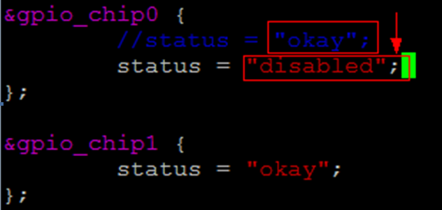

          - Register the GPIO.
gpio_request(gpio_num, NULL);
- Each GPIO group contains eight GPIO pins.
- gpio_num indicates the number of the GPIO to be operated, and equals (GPIO group number x 8 + Offset within the group). For example, the number of GPIO4_2 is 34 (4 x 8 + 2).
          - Set the GPIO direction.
gpio_direction_input(gpio_num)
The direction of the GPIO pin that is used as the interrupt source must be configured as input.
          - Map the number of the GPIO to be operated to the number of the corresponding interrupt.
irq_num = gpio_to_irq(gpio_num);
The interrupt number is the return value of gpio_to_irq(gpio_num).
          - Register the interrupt.
request_irq(irq_num, gpio_dev_test_isr, irqflags, "gpio_dev_test", &gpio_irq_type))
Irqflags indicates the type of the interrupt to be registered. The common interrupt types are as follows:
- IRQF_SHARED: shared interrupt
- IRQF_TRIGGER_RISING: rising-edge-triggered interrupt
- IRQF_TRIGGER_FALLING: falling-edge-triggered interrupt
- IRQF_TRIGGER_HIGH: high-level-triggered interrupt
- IRQF_TRIGGER_LOW: low-level-triggered interrupt
          - Release the registered interrupt number and GPIO number.
free_irq(gpio_to_irq(gpio_num), &gpio_irq_type);
gpio_free(gpio_num);
The code instance is as follows:
The following code instance is a sample program of the GPIO operation, which only serves as a reference for customers when they develop kernel-mode GPIO operation programs. The code has no actual application function.
#include <linux/delay.h>
#include <linux/gpio.h>
#include <linux/interrupt.h>
#include <linux/module.h>
//Module parameters, including the GPIO group number, offset within the group, direction, and initial output value
static unsigned int gpio_chip_num = 4;
module_param(gpio_chip_num, uint, S_IRUGO);
MODULE_PARM_DESC(gpio_chip_num, "gpio chip num");

static unsigned int gpio_offset_num = 2;
module_param(gpio_offset_num, uint, S_IRUGO);
MODULE_PARM_DESC(gpio_offset_num, "gpio offset num");

static unsigned int gpio_dir = 1;
module_param(gpio_dir, uint, S_IRUGO);
MODULE_PARM_DESC(gpio_dir, "gpio dir");

static unsigned int gpio_out_val = 1;
module_param(gpio_out_val, uint, S_IRUGO);
MODULE_PARM_DESC(gpio_out_val, "gpio out val");

//Module parameter, which indicates the interrupt trigger type
/*
* 0 - disable irq
* 1 - rising edge triggered
* 2 - falling edge triggered
* 3 - rising and falling edge triggered
* 4 - high level triggered
* 8 - low level triggered
*/
static unsigned int gpio_irq_type = 0;
module_param(gpio_irq_type, uint, S_IRUGO);
MODULE_PARM_DESC(gpio_irq_type, "gpio irq type");

spinlock_t lock;

static int gpio_dev_test_in(unsigned int gpio_num)
{
//Set the direction to input.
if (gpio_direction_input(gpio_num)) {
pr_err("[%s %d]gpio_direction_input fail!\n",
__func__, __LINE__);
return -EIO;
}
//Read the GPIO input value.
pr_info ("[%s %d]gpio%d_%d in %d\n", __func__, __LINE__,
gpio_num / 8, gpio_num % 8,
gpio_get_value(gpio_num));

return 0;
}
//Interrupt handler function
static irqreturn_t gpio_dev_test_isr(int irq, void *dev_id)
{
pr_info("[%s %d]\n", __func__, __LINE__);

return IRQ_HANDLED;
}

static int gpio_dev_test_irq(unsigned int gpio_num)
{
unsigned int irq_num;
unsigned int irqflags = 0;
//Set the direction to input.
if (gpio_direction_input(gpio_num)) {
pr_err("[%s %d]gpio_direction_input fail!\n",
__func__, __LINE__);
return -EIO;
}

switch (gpio_irq_type) {
case 1:
irqflags = IRQF_TRIGGER_RISING;
break;
case 2:
irqflags = IRQF_TRIGGER_FALLING;
break;
case 3:
irqflags = IRQF_TRIGGER_RISING |
IRQF_TRIGGER_FALLING;
break;
case 4:
irqflags = IRQF_TRIGGER_HIGH;
break;
case 8:
irqflags = IRQF_TRIGGER_LOW;
break;
default:
pr_info("[%s %d]gpio_irq_type error!\n",
__func__, __LINE__);
return -1;
}

pr_info("[%s %d]gpio_irq_type = %d\n", __func__, __LINE__, gpio_irq_type);
irqflags |= IRQF_SHARED;
//Map the interrupt number based on the GPIO number.
irq_num = gpio_to_irq(gpio_num);
//Register the interrupt.
if (request_irq(irq_num, gpio_dev_test_isr, irqflags,
"gpio_dev_test", &gpio_irq_type)) {
pr_info("[%s %d]request_irq error!\n", __func__, __LINE__);
return -1;
}

return 0;
}

static void gpio_dev_test_irq_exit(unsigned int gpio_num)
{
unsigned long flags;

pr_info("[%s %d]\n", __func__, __LINE__);
//Release the registered interrupt.
spin_lock_irqsave(&lock, flags);
free_irq(gpio_to_irq(gpio_num), &gpio_irq_type);
spin_unlock_irqrestore(&lock, flags);
}
static int gpio_dev_test_out(unsigned int gpio_num, unsigned int gpio_out_val)
{
//Set the direction to output and output an initial value.
if (gpio_direction_output(gpio_num, !!gpio_out_val)) {
pr_err("[%s %d]gpio_direction_output fail!\n",
__func__, __LINE__);
return -EIO;
}

pr_info("[%s %d]gpio%d_%d out %d\n", __func__, __LINE__,
gpio_num / 8, gpio_num % 8, !!gpio_out_val);
return 0;
}

static int __init gpio_dev_test_init(void)
{
unsigned int gpio_num;
int status = 0;

pr_info("[%s %d]\n", __func__, __LINE__);

spin_lock_init(&lock);

gpio_num = gpio_chip_num * 8 + gpio_offset_num;
//Register the number of the GPIO to be operated.
if (gpio_request(gpio_num, NULL)) {
pr_err("[%s %d]gpio_request fail! gpio_num=%d \n", __func__, __LINE__, gpio_num);
return -EIO;
}

if (gpio_dir) {
status = gpio_dev_test_out(gpio_num, gpio_out_val);
} else {
if (gpio_irq_type)
status = gpio_dev_test_irq(gpio_num);
else
status = gpio_dev_test_in(gpio_num);
}

if (status)
gpio_free(gpio_num);

return status;
}
module_init(gpio_dev_test_init);

static void __exit gpio_dev_test_exit(void)
{
unsigned int gpio_num;

pr_info("[%s %d]\n", __func__, __LINE__);

gpio_num = gpio_chip_num * 8 + gpio_offset_num;

if (gpio_irq_type)
gpio_dev_test_irq_exit(gpio_num);
//Release the registered GPIO number.
gpio_free(gpio_num);
}

module_exit(gpio_dev_test_exit);

MODULE_DESCRIPTION("GPIO device test Driver sample");
MODULE_LICENSE("GPL");
----End

GPIO Operation Example in User Mode
The following operation example implements the GPIO read and write operations in user mode:
          - Export the number of the GPIO to be operated.
fp = fopen("/sys/class/gpio/export", "w");
fprintf(fp, "%d", gpio_num);
fclose(fp);
- Each GPIO group contains eight GPIO pins.
- gpio_num indicates the number of the GPIO to be operated, and equals (GPIO group number x 8 + Offset within the group). For example, the number of GPIO4_2 is 34 (4 x 8 + 2).
          - Set the GPIO direction.
fp = fopen("/sys/class/gpio/gpio%d/direction", "rb+");
For the input: fprintf(fp, "in");
For the output: fprintf(fp, "out");
fclose(fp);
          - Check the GPIO input value or set the GPIO output value.
fp = fopen("/sys/class/gpio/gpio%d/value", "rb+");
Check the input value: fread(buf, sizeof(char), sizeof(buf) - 1, fp);
Set the output to low level:
strcpy(buf,"0");
fwrite(buf, sizeof(char), sizeof(buf) - 1, fp);
Set the output to high level:
strcpy(buf,"1");
fwrite(buf, sizeof(char), sizeof(buf) - 1, fp);
          - Unexport the number of the operated GPIO.
fp = fopen("/sys/class/gpio/unexport", "w");
fprintf(fp, "%d", gpio_num);
fclose(fp);
The code instance is as follows:
The following code instance is a sample program of the GPIO operation, which only serves as a reference for customers when they develop user-mode GPIO operation programs. The code has no actual application function.
#include <stdio.h>
#include <string.h>

int gpio_test_in(unsigned int gpio_chip_num, unsigned int gpio_offset_num)
{
FILE *fp;
char file_name[50];
unsigned char buf[10];
unsigned int gpio_num;

gpio_num = gpio_chip_num * 8 + gpio_offset_num;

sprintf(file_name, "/sys/class/gpio/export");
fp = fopen(file_name, "w");
if (fp == NULL) {
printf("Cannot open %s.\n", file_name);
return -1;
}
fprintf(fp, "%d", gpio_num);
fclose(fp);

sprintf(file_name, "/sys/class/gpio/gpio%d/direction", gpio_num);
fp = fopen(file_name, "rb+");
if (fp == NULL) {
printf("Cannot open %s.\n", file_name);
return -1;
}
fprintf(fp, "in");
fclose(fp);

sprintf(file_name, "/sys/class/gpio/gpio%d/value", gpio_num);
fp = fopen(file_name, "rb+");
if (fp == NULL) {
printf("Cannot open %s.\n", file_name);
return -1;
}
memset(buf, 0, 10);
fread(buf, sizeof(char), sizeof(buf) - 1, fp);
printf("%s: gpio%d_%d = %d\n", __func__,
gpio_chip_num, gpio_offset_num, buf[0]-48);
fclose(fp);

sprintf(file_name, "/sys/class/gpio/unexport");
fp = fopen(file_name, "w");
if (fp == NULL) {
printf("Cannot open %s.\n", file_name);
return -1;
}
fprintf(fp, "%d", gpio_num);
fclose(fp);

return (int)(buf[0]-48);
}

int gpio_test_out(unsigned int gpio_chip_num, unsigned int gpio_offset_num,
unsigned int gpio_out_val)
{
FILE *fp;
char file_name[50];
unsigned char buf[10];
unsigned int gpio_num;

gpio_num = gpio_chip_num * 8 + gpio_offset_num;

sprintf(file_name, "/sys/class/gpio/export");
fp = fopen(file_name, "w");
if (fp == NULL) {
printf("Cannot open %s.\n", file_name);
return -1;
}
fprintf(fp, "%d", gpio_num);
fclose(fp);

sprintf(file_name, "/sys/class/gpio/gpio%d/direction", gpio_num);
fp = fopen(file_name, "rb+");
if (fp == NULL) {
printf("Cannot open %s.\n", file_name);
return -1;
}
fprintf(fp, "out");
fclose(fp);

sprintf(file_name, "/sys/class/gpio/gpio%d/value", gpio_num);
fp = fopen(file_name, "rb+");
if (fp == NULL) {
printf("Cannot open %s.\n", file_name);
return -1;
}
if (gpio_out_val)
strcpy(buf,"1");
else
strcpy(buf,"0");

fwrite(buf, sizeof(char), sizeof(buf) - 1, fp);
printf("%s: gpio%d_%d = %s\n", __func__,
gpio_chip_num, gpio_offset_num, buf);
fclose(fp);

sprintf(file_name, "/sys/class/gpio/unexport");
fp = fopen(file_name, "w");
if (fp == NULL) {
printf("Cannot open %s.\n", file_name);
return -1;
}
fprintf(fp, "%d", gpio_num);
fclose(fp);

return 0;

}
----End

Appendix

Partitioning a Storage Device
You can check the current partition status of a device by following section 1.7.1.1 "Checking the Current Partition Status of a Storage Device." If the device is not partitioned, you need to partition it as follows:
- If partitions exist, skip the operations in this section and go to section 1.7.2 "Formatting a Partition."
- If partitions do not exist, enter the fdisk command at the command prompt of the console:
~ $ fdisk device node
Press Enter and enter the m command. Continue with the operations based on the help information.
The device node depends on the type of the actual storage device. For details, see the operation instances in preceding chapters.

Checking the Current Partition Status of a Storage Device
To check the current partition status of a storage device, enter the p command at the command prompt of the console:
Command (m for help): p
The partition status similar to the following is displayed:
Disk /dev/mmc/blk1/disc: 127 MB, 127139840 bytes
8 heads, 32 sectors/track, 970 cylinders
Units = cylinders of 256 * 512 = 131072 bytes
Device Boot Start End Blocks Id System
The preceding information indicates that the device is not partitioned. In this case, you need to partition the device by following section 1.7.1.2 "Creating Partitions for a Storage Device.", and save the partition information by following section 1.7.1.3 "Saving the Partition Information."

Creating Partitions for a Storage Device
Perform the following steps:
          - Create partitions.
Under the prompt, enter the n command to create partitions.
Command (m for help): n
The following information is displayed on the console:
Command action
e extended
p primary partition (1-4)
          - Create the primary partition.
Enter the p command to select the primary partition:
p
          - Select the number of partitions.
In this example, set the number to 1, that is, enter 1.
Partition number (1-4): 1
The following information is displayed on the console:
First cylinder (1-970, default 1):
          - Select the start cylinder.
This example takes the default value 1. Press Enter.
Using default value 1
          - Select the end cylinder.
This example takes the default value 970. Press Enter.
Last cylinder or +size or +sizeM or +sizeK (1-970, default 970):
Using default value 970
          - Select a data format for the storage device.
The default value is Linux. This example takes Win95 FAT; therefore, run the t command to change the value.
Command (m for help): t
Selected partition 1
Then run the following command:
Hex code (type L to list codes): b
Run the l command to view the details of all the partitions of the fdisk.
Changed system type of partition 1 to b (Win95 FAT32)
          - Check the status of partitions.
Enter the p command to view the partition information:
Command (m for help): p
If the partition information is displayed on the console, the partitioning is successful.
----End

Saving the Partition Information
To save the partition information, run the following command:
Command (m for help): w
If the following information is displayed on the console, the partition information is successfully saved:
The partition table has been altered!
Calling ioctl() to re-read partition table.
…………
~ $

Formatting a Partition
Perform the following operations:
- If partitions are formatted, skip the operations in this section and go to section 1.7.3 "Mounting a Directory."
- If partitions are not formatted, run the mkdosfs command to format the partitions:
~ $ mkdosfs –F 32 Partition name
The name of a partition depends on the type of the actual storage device. For details, see the operation instances in preceding chapters.
If no error information is displayed on the console, a partition is formatted successfully:
~ $

Mounting a Directory
Run the mount command to mount the partitions to the /mnt directory. Then you can read and write files.
~ $ mount -t vfat Partition name /mnt
The name of a partition depends on the type of the actual storage device. For details, see the operation instances in preceding chapters.

Reading/Writing to a File
There are various read and write operations. This section takes the cp command as an example to read and write to a file.
To write to a file, copy the test.txt file in the current directory to the mnt directory of a storage device by running the following command:
~ $ cp ./test.txt /mnt

Huawei LiteOS
This chapter is for reference only in the Huawei LiteOS system solution.

Operation Guide to the I²C Module

Function Description
The inter-integrated circuit (I²C) module is used by the CPU to read/write data from/to the slave device connected to the I²C bus.

Module Compilation
The path of the source code for this module is drivers/i2c. To access the I²C device, you need to specify the I²C source code path and header file path in the compilation script. After compilation is successful, the library file libi2c.a is generated in out. You need to specify this library file by using the parameter -li2c during linking.
The paths in this document refer to the root directory of the Huawei LiteOS source code or the relative paths.

Samples

Initializing the I²C Module
To initialize the I²C driver, perform the following steps:
          - Initialize the driver by calling the following API:
i2c_dev_init();
          - Configure pin multiplexing based on the device hardware features (by the developer).
For details, see the "3. Pin Control Registers" sheet in the Hi3516C V500_PINOUT_EN.
          - Access the device by calling the read/write function of the module as required. For details, see section 2.1.3.2 "Accessing I2C Peripherals by Calling Driver Functions" and 2.1.3.3 "Accessing I2C Peripherals by Using Device Nodes."
----End

Accessing I²C Peripherals by Calling Driver Functions
          - Define an I²C device description structure.
struct i2c_client client;
          - Call the client_attach to associate the client with the corresponding controller.
Function prototype:
int client_attach(struct i2c_client * client, int adapter_index)
adapter_index: number of the associated I²C bus number. For example, the value is 0 when I²C0 is to be operated.
          - In an interrupt context, call the standard read and write functions provided by the I²C to read and write peripherals.
Read: ret = i2c_transfer(struct i2c_adapter *adapter, struct i2c_msg *msgs, int count);
Write: ret = i2c_master_send(struct i2c_client *client, const char *buf, int count);
In an interrupt context, call the read and write functions provided by the I²C driver layer to read and write the peripherals.
Read: ret = hi_i2c_transfer(struct i2c_adapter *adapter, struct i2c_msg *msgs, int count);
Write: ret = hi_i2c_master_send(struct i2c_client *client, const char *buf, int count);
- The client parameter indicates the client structure of the I²C peripheral device obtained in Step 2.
- The buf parameter indicates the register and data to be read and written.
- The count parameter indicates the buffer length.
- The msg parameter indicates the initial address of two i2c_msg during the read operation.
The code instance is as follows:
The following code instance is a sample program, which serves only as a reference when customers call the I²C driver to access peripherals and has no actual function.
struct i2c_client i2c_client_obj; //i2c control structure
#define SLAVE_ADDR 0x34 //I²C device address
#define SLAVE_REG_ADDR 0x300f //I²C device register address
/* client initialization */
int i2c_client_init(void)
{
int ret = 0;
struct i2c_client * i2c_client0 = &i2c_client_obj;
i2c_client0->addr = SLAVE_ADDR >> 1;
ret = client_attach(i2c_client0, 0);
if(ret) {
dprintf("Fail to attach client!\n");
return -1;
}
return 0;
}
UINT32 sample_i2c_write(void)
{
int ret;
struct i2c_client * i2c_client0 = & i2c_client_obj;
char buf[4] = {0};
i2c_client_init();
buf[0] = SLAVE_REG_ADDR & 0xff;
buf[1] = (SLAVE_REG_ADDR >> 8) & 0xff;
buf[2] = 0x03; //Value written to the I²C device

//Call the standard write function of the I²C driver to perform the write operation.
ret = i2c_master_send(i2c_client0, &buf, 3);
return ret;
}
UINT32 sample_i2c_read(void)
{
int ret;
struct i2c_client *i2c_client0 = & i2c_client_obj;
struct i2c_rdwr_ioctl_data rdwr;
struct i2c_msg msg[2];
unsigned char recvbuf[4];

memset(recvbuf, 0x0 ,4);
i2c_client_init();

msg[0].addr = SLAVE_ADDR >> 1;
msg[0].flags = 0;
msg[0].len = 2;
msg[0].buf = recvbuf;

msg[1].addr = SLAVE_ADDR >> 1;
msg[1].flags = 0;
msg[1].flags |= I2C_M_RD;
msg[1].len = 1;
msg[1].buf = recvbuf;

rdwr.msgs = &msg[0];
rdwr.nmsgs = 2;

recvbuf[0] = SLAVE_REG_ADDR & 0xff;
recvbuf[1] = (SLAVE_REG_ADDR >> 8) & 0xff;

i2c_transfer(i2c_client0->adapter, msg, rdwr.nmsgs);
dprintf("val = 0x%x\n",recvbuf[0]); //buf[0] saves the value read from or written to the I²C device.
return ret;
}
----End

Accessing I²C Peripherals by Using Device Nodes
          - Open the device file corresponding to the I²C bus to obtain the file descriptor.
fd = open("/dev/i2c-0",O_RDWR);
Call the i2c_dev_init() function to register the device file if it has not been registered.
          - Configure the peripheral address, bit width of peripheral registers, and data bit width of peripherals by using ioctl:
ret = ioctl(fd, I2C_SLAVE_FORCE, device_addr);
ioctl(fd, I2C_16BIT_REG, 0);
ioctl(fd, I2C_16BIT_DATA, 0);

The related macro definitions are in drivers/i2c/include/hi_i2c.h.
          - Use the following functions to perform data read and write operations:
ioctl(fd, I2C_RDWR, &rdwr);
write(fd, buf, count);
- In step 2, when the register bit width and data width are configured, if the third parameter of ioctl is 0, the bit width is 8 bits; if it is 1, the bit width is 16 bits.
- In step 3, the macro definition applied when the ioctl function is used to perform read and write operations is stored in the drivers/i2c/include/i2c-dev.h header file.
For details about the code samples, refer to the following file:
drivers/i2c/src/i2c_shell.c
- The preceding code instance is a sample program, which serves only as a reference when customers access I²C peripherals by using the file system and has no actual function.
- When users call the read and write interfaces to perform the I²C read and write operations, buf contains the register address and the data bytes to be operated, and count indicates the total number of bytes occupied by the register address and data to be operated.
----End

shell Commands

i2c_read
You can read from the I²C peripheral by running the i2c_read command in the console.
i2c_read <i2c_num> <device_addr> <reg_addr> <end_reg_addr> [reg_width] [data_width] [addr_width]
For example, to read the registers with the address ranging from 0x3000 to 0x3010 of the device IMX178 that is mounted to the I²C controller 0, run the following command:
i2c_read 0x0 0x34 0x3000 0x3010 2 1 7
i2c_num: I²C controller ID (corresponding to the I²C controller ID in the Hi3516C V500 Professional Smart IP Camera SoC Data Sheet)
- device_addr: peripheral device address
- reg_addr: start address for reading the peripheral registers
- end_reg_addr: end address for reading the peripheral registers
- reg_width: bit width of peripheral registers (The value is 8-bit or 16-bit. The value 2 indicates 16-bit, and 1 indicates 8-bit.)
- data_width: data width of peripherals (The value is 8-bit or 16-bit. The value 2 indicates 16-bit, and 1 indicates 8-bit.)
- addr_width: bit width of peripheral addresses (The value is 7-bit or 10-bit. The value 7 indicates 7-bit, and the value 10 indicates 10-bit.)

i2c_write
You can write to the I²C peripheral by running the i2c_write command in the console.
i2c_write <i2c_num> <device_addr> <reg_addr> <reg_value> [reg_width] [data_width] [addr_width]
For example, to write 0x10 to the register with the address 0x300f of the device IMX178 that is mounted to the I²C controller 0 at 400 kbit/s, run the following command:
i2c_write 0x0 0x34 0x300f 0x00 2 1 7
i2c_num: I²C controller ID (corresponding to the I²C controller ID in the Hi3516C V500 Professional Smart IP Camera SoC Data Sheet)
- device_addr: peripheral device address
- reg_addr: start address for writing to the peripheral registers
- reg_value: data for writing to the peripheral registers
- reg_width: bit width of peripheral registers (The I²C controller supports the 8-bit or 16-bit width.)
- data_width: data width of peripherals (The I²C controller supports the 8-bit or 16-bit width.)
- addr_width: bit width of peripheral addresses (The value is 7-bit or 10-bit. The value 7 indicates 7-bit, and the value 10 indicates 10-bit.)

API References
This functional module provides the following APIs:
- i2c_dev_init: Initializes an I²C device.
- i2c_master_recv: Reads I²C data.
- i2c_master_send: Writes I²C data.
- i2c_transfer: Transfers I²C data.
- client_attach: Associates the client and the adapter.
- client_deinit: Disassociates the client from the adapter.

i2c_dev_init
[Description]
Initializes an I²C device.
[Syntax]
int i2c_dev_init(void);
[Parameter]
None
[Return Value]
Return Value | Description
0 | Success
Other values | Failure

i2c_master_recv
[Description]
Reads I²C data.
[Syntax]
int i2c_master_recv(const struct i2c_client *client, char *buf, int count);
[Parameter]
Parameter Name | Description | Input/Output
client | I²C device description structure | Input
buf | Data buffer | Output
count | Number of transmitted bytes | Input

[Return Value]
Return Value | Description
Non-negative value | Read/Write length
Negative value | Read/Write failure

i2c_master_send
[Description]
Writes I²C data.
[Syntax]
int i2c_master_send(const struct i2c_client *client, char *buf, int count);
[Parameter]
Parameter Name | Description | Input/Output
client | I²C device description structure | Input
buf | Data buffer | Input
count | Number of transmitted bytes | Input

[Return Value]
Return Value | Description
Non-negative value | Read/Write length
Negative value | Read/Write failure

i2c_transfer
[Description]
Transfers I²C data.
[Syntax]
int i2c_transfer(struct i2c_adapter *adapter, struct i2c_msg *msgs, int count);
[Parameter]
Parameter | Description | Input/Output
adapter | Adapter of the I²C controller | Input
msgs | msg arrays to be transferred | Input
count | Number of messages to be transferred | Input

[Return Value]
Return Value | Description
Non-negative values | Number of transferred messages
Negative values | Read/Write failure

client_attach
[Description]
Associates the client and the adapter.
[Syntax]
int client_attach(struct i2c_client * client, int adapter_index);
[Parameter]
Parameter | Description | Input/Output
client | Client structure | Input
adapter_index | Number of the associated host | Input

[Return Value]
Return Value | Description
0 | Success
Other values | Failure

client_deinit
[Description]
Disassociates the client from the adapter.
[Syntax]
int client_deinit(struct i2c_client * client);
[Parameter]
Parameter | Description | Input/Output
client | Client structure | Input

[Return Value]
Return Value | Description
0 | Success
Other values | Failure

Data Structure
i2c_client: I²C slave device structure.

i2c_client
[Description]
I²C slave device structure
[Definition]
struct i2c_client {
unsigned short flags;
unsigned short addr;
char name[I2C_NAME_SIZE];
struct i2c_adapter *adapter;
struct i2c_driver *driver;
struct device dev;
int irq;
struct list_head detected;
};
[Member]
Member | Description
flags | Flag
addr | Address
name | Name
adapter | Data structure pointer at the adaptation layer
driver | Data structure pointer at the driver layer
dev | Device structure
irq | Interrupt ID
detected | Linked list header

Operation Guide to the SPI Module

Function Description
The serial peripheral interface (SPI) module is used to access the slave device connected to the SPI bus.

Module Compilation
The path of the source code for this module is drivers/spi. you need to specify the SPI source code path and header file path in the compilation script. After compilation is successful, the library file libspi.a is generated in the out directory. You need to specify this library file by using the parameter -lspi during linking.
The paths in this document refer to the root directory of the Huawei LiteOS source code or the relative paths.

Samples

Initializing the SPI Module
To initialize the SPI driver, perform the following steps:
          - Initialize the driver by calling the following API:
spi_dev_init();
          - Configure the multiplexing functions of related pins based on the device hardware features (by the developer).
For details, see the "3. Pin Control Registers" sheet in the Hi3516C V500_PINOUT_EN.
          - Access the device by calling the read/write function of the module as required. For details, see section 2.2.3.2 "Accessing SPI Peripherals by Calling Driver Functions" and 2.2.3.3 "Accessing SPI Peripherals by Using Device Nodes."
----End

Accessing SPI Peripherals by Calling Driver Functions
          - Define an SPI data transmission structure.
struct spi_ioc_transfer transfer[1];
          - Initialize spi_ioc_transfer.
transfer[0].tx_buf = (uint32_t)buf;
transfer[0].rx_buf = (uint32_t)buf;
transfer[0].len = DEV_WIDTH + REG_WIDTH + DATA_WIDTH;
transfer[0].cs_change = 1;
- SPI_NUM indicates the ID of the SPI bus that needs to be operated.
- cs_change indicates whether to invalidate the CS to the device after the transmission operation is completed. The value 1 indicates that the CS is invalid after the transmission operation is completed. Otherwise, the CS is valid.
          - Access the SPI device by calling spidev_transfer.
retval = spi_dev_set(bus_num, csn, &transfer[0]);
The code instance is as follows:
The following code instance is a sample program for reading and writing SPI peripherals. The code serves only as a reference when customers call the SPI driver to access peripherals and has no actual function.
#define DEV_WIDTH 1
#define REG_WIDTH 2
#define DATA_WIDTH 1
#define SPI_NUM 0
#define SPI_DEVICE_ADDR 0x82
#define SPI_REG_ADDR 0x0

int ssp_func_read(unsigned char *data)
{
unsigned char buf[0x10];
struct spi_ioc_transfer transfer[1];
int retval = 0;

transfer[0].tx_buf = buf;
transfer[0].rx_buf = buf;
transfer[0].len = DEV_WIDTH + REG_WIDTH + DATA_WIDTH;
transfer[0].cs_change = 1;
transfer[0].speed = 20000;
memset(buf, 0, sizeof(buf));
/* Determine whether the read and write bits are configured from low to high or high to low according to the SPI transmission mode. */
buf[0] = (SPI_DEVICE_ADDR & 0xff) | 0x80 ;
buf[1] = 0x0;
buf[2] = (SPI_REG_ADDR & 0xff);

retval = spi_dev_set(0,0,&transfer[0]);
*data = buf[DEV_WIDTH + REG_WIDTH];
return retval ;
}

int ssp_func_write(void)
{
unsigned char buf[0x10];
struct spi_ioc_transfer transfer[1];
int retval = 0;

transfer[0].tx_buf = buf;
transfer[0].rx_buf = buf;
transfer[0].len = DEV_WIDTH + REG_WIDTH + DATA_WIDTH;
transfer[0].cs_change = 1;
transfer[0].speed = 20000;
memset(buf, 0, sizeof(buf));

/* Determine whether the read and write bits are configured from low to high or high to low according to the SPI transmission mode. */
buf[0] = (SPI_DEVICE_ADDR & 0xff) &(~0x80) ;
buf[1] = 0x0;
buf[2] = (SPI_REG_ADDR & 0xff);
buf[3] = 0x1; //data to be written

retval = spi_dev_set(0,0,&transfer[0]);
return retval ;
}
----End

Accessing SPI Peripherals by Using Device Nodes
          - Open the device file corresponding to the SPI bus to obtain the file descriptor.
fd = open("/dev/spidev0.0", O_RDWR);
Call the spidev_init function to register the device file if it has not been registered.
          - Configure the SPI transfer mode by using ioctl:
value = SPI_MODE_3 | SPI_LSB_FIRST;
ret = ioctl(fd, SPI_IOC_WR_MODE, &value);
- SPI_MODE_3 indicates the mode in which the SPI clock and phase are both 1.
- SPI_LSB_FIRST indicates that the format of each data segment is big endian during SPI transfer.

The related macro definitions are in drivers/spi/include/spidev.h.
For details about the clock, phase, endian mode of the SPI, see the Hi3516C V500 Professional Smart IP Camera SoC Data Sheet.
          - Read and write by using ioctl.
ret = ioctl(fd, SPI_IOC_MESSAGE, mesg);
- mesg indicates the start address of the struct spi_ioc_transfer structure array that transfers a message frame.
- SPI_IOC_MESSAGE indicates the command used to read and write messages in full-duplex mode.
The code instance is as follows:
The following code instance is a sample program, which serves only as a reference when customers access SPI peripherals by using the file system and has no actual function.
#define SPI_DEV_ADDR 0x02 //Component address
INT32 spi_dev_read(unsigned char reg_addr , unsigned char * data )
{
struct file * fd = NULL;
int ret = 0;
unsigned char buf[0x10];
struct spi_ioc_transfer transfer[1];

fd = open("/dev/spidev0.0", O_RDWR);
if ( fd == 0 ) {
dprintf("open /dev/spidev0.0 fail! \n");
return -1;
}
dprintf("open success !\n \n");

value = SPI_MODE_3 | SPI_LSB_FIRST;
ret = ioctl(fd, SPI_IOC_WR_MODE, &value);

memset(transfer, 0, sizeof transfer);
transfer[0].tx_buf = (uint32_t)buf;
transfer[0].rx_buf = (uint32_t)buf;
transfer[0].len = 3;
transfer[0].cs = 0;
buf[0] = SPI_DEV_ADDR | 0x80; //dev addr
buf[1] = reg_addr & 0xff ; //reg_addr
buf[2] = 0;
ret = ioctl(fd, SPI_IOC_MESSAGE, transfer);
if (ret < 0)
{
dprintf("ioctl spi fail ! \n");
close(fd);
return -1;
}
* data = buf[2];
close(fd);
return 0 ;
}

INT32 spi_dev_write(unsigned char reg_addr , unsigned char reg_val)
{
struct file * fd;
int ret = 0;
unsigned char buf[0x10];
struct spi_ioc_transfer transfer[1];
fd = open("/dev/spidev0.0", O_RDWR);
if ( fd == 0 ) {
dprintf("open /dev/spidev0.0fail! \n");
return -1;
}
dprintf("open success !\n \n");
value = SPI_MODE_3 | SPI_LSB_FIRST;
ret = ioctl(fd, SPI_IOC_WR_MODE, &value);

memset(transfer, 0, sizeof transfer);
transfer[0].tx_buf = (uint32_t)buf;
transfer[0].rx_buf = (uint32_t)buf;
transfer[0].len = 3;
transfer[0].cs = 0;

buf[0] = SPI_DEV_ADDR & (~0x80); //dev addr
buf[1] = reg_addr & 0xff; //reg_addr
buf[2] = reg_val & 0xff;

ret = ioctl(fd, SPI_IOC_MESSAGE, transfer);
if (ret < 0)
{
dprintf("ioctl spi fail ! \n");
close(fd);
return -1;
}
close(fd);
return 0 ;
}
----End

shell Commands

ssp_read
You can read from the SPI peripheral by running the spi_read command in the console.
ssp_read <spi_num> <csn> <dev_addr> <reg_addr> [num_reg] [dev_width] [reg_width] [data_width]
num_reg can be omitted. The default value is 1 (indicating one register).
dev_width, reg_width, and data_width can be omitted. The default values are 1 (indicating 1 byte).
For example, to read the 0x0 register of the device with the address 0x2 that is mounted to CS0 of SPI controller 0, run the following command:
ssp_read 0x0 0x0 0x2 0x0 0x10 0x1 0x1 0x1
- spi_num: SPI controller ID (corresponding to the SPI controller ID in the Hi3516C V500 Professional Smart IP Camera SoC Data Sheet)
- csn: CS number
- dev_addr: peripheral device address
- reg_addr: start address of peripheral registers
- num_reg: number of read peripheral registers
- dev_width: bit width of peripheral addresses (8-bit)
- reg_width: bit width of peripheral register addresses (8-bit)
- data_width: data width of peripherals (8-bit)
This SPI read/write command supports only the read/write operation of the sensor.

ssp_rwrite
You can write to the SPI peripheral by running the spi_write command in the console.
ssp_write <spi_num> <csn> <dev_addr> <reg_addr> <data> [dev_width] [reg_width] [data_width]
dev_width, reg_width, and data_width can be omitted. The default values are 1 (indicating 1 byte). For example, to write to the 0x0 register of the device with the address 0x2 that is mounted to CS0 of SPI controller 0, run the following command:
ssp_write 0x0 0x0 0x2 0x0 0x65 0x1 0x1 0x1
- spi_num: SPI controller ID (corresponding to the SPI controller ID in the Hi3516C V500 Professional Smart IP Camera SoC Data Sheet)
- csn: CS number
- dev_addr: peripheral device address
- reg_addr: peripheral register address
- data: data for writing to the peripheral registers
- dev_width: bit width of peripheral addresses (8-bit)
- reg_width: bit width of peripheral register addresses (8-bit)
- data_width: data width of peripherals (8-bit)
This SPI read/write command supports only the read/write operation of the sensor.

API References
spi_dev_set: This API is used to initiates read/write operations on the SPI device.

spi_dev_set
[Description]
This API is used to initiates read/write operations on the SPI device.
[Syntax]
int hi_spidev_set(int host_no, int cs_no, struct spi_ioc_transfer *transfer);
[Requirements]
- Header file: spi.h hisoc/spi.h
- Library file: libspi.a
[Parameter]
Parameter Name | Description | Input/Output
host_no | ID of the operated controller | Input
cs_no | CS | Input
transfer | Transmission control structure pointer  Value: Members are defined by the user. For details, see section 2.2.6 "Data Structure." | Input

[Return Value]
Return Value | Description
Non-negative value | Read/Write length
Negative value | Read/Write failure

Data Structure
spi_ioc_transfer: SPI transmission control data structure.

spi_ioc_transfer
[Description]
SPI transmission control data structure
[Definition]
struct spi_ioc_transfer {
const char *tx_buf;
char *rx_buf;
unsigned len;
unsigned cs_change;
unsigned int speed;
};
[Member]
Member | Description
tx_buf | Write buffer address
rx_buf | Read buffer address
len | Read/Write length
cs_change | CS change flag
speed | Rate

Operation Guide to the UART Module

Function Description
The universal asynchronous receiver transmitter (UART) module is an asynchronous serial communication interface. It implements communication with other UART devices (such as serial terminals and MCUs).

Module Compilation
The path of the source code for this module is drivers/uart. To access the UART device, you need to specify the UART source code path and header file path in the compilation script. After compilation is successful, the library file libuart.a will be generated in the out directory. You need to specify this library file by using the parameter -luart during linking.

Samples
          - Call the following API in the initialization function to register the UART driver:
uart_dev_init();
As the shell uses UART0 for communication interaction and debugging information display, you need to register the UART driver before initializing modules that are dependent on the UART module, such as the console and shell.
To receive data in DMA mode, initialize the DMAC in the initialization function.
hi_dmac_init();
          - Configure the multiplexing functions of related pins based on the device hardware features (by the developer).
For details, see the "3. Pin Control Registers" sheet in the Hi3516C V500_PINOUT_EN.
          - Call the open function by using the /dev/ uartdev-x node to enable the specified UART.
          - Call the ioctl configurations after enabling the UART.
          - Call the read and write functions to read and send data, and block read by using the select.
          - Call the close function to disable the UART when it is not used. After the UART controller is disabled, data in the serial line is not received any more.
----End

shell Commands
The related shell commands include uart_read, uart_write, uart_config, and uart_close, which are used to read data, send data, configure the UART, and disable the UART respectively.

uart_read
This command is used to read data with the specified length from the UART receive buffer.
- Create a thread to receive data. The format is uart_read <num> <len>
- Run uart_read –q to exit the receiving thread and stop reading data.
- num: UART controller ID (corresponding to the UART controller ID)
- len: length of data to be read at a time in the receive buffer
- Sample: uart_read 2 100
This command is used to read 100-byte data from UART2.

uart_write
This command is used to send specified data (characters) by using the UART controller.
- Format: uart_write <num> <buf>
- num: UART controller ID
- buf: data transmission buffer, ASCII mode
- Sample: uart_wirte 2 abcdefghijklmnopqrstuvwxy
This command is used to send a character string by using UART2.

uart_config
This command is used to configure the UART baud rate, blocked read, DMA receive, and data bit.
- Format: uart_config <num> <cmd> <arg>
- num: UART controller ID
- cmd: command ID. 0x101 indicates configuring the baud rate. For details about the configuration, see Table 1-1.
- arg: parameter corresponding to the command ID. For example, to configure the baud rate, the parameter can be 2400, 9600, or 115200.
- Sample: uart_config 2 0x101 9600
This command is used to set the baud rate of UART2 to 9600.

uart_close
Disable the enabled UART controller. The UART controller is enabled when uart_open, uart_write, or uart_cofing is called.
Format: uart_close <num>
Data is not received after the UART is disabled. The UART is enabled again when the read or write function is called, and it is configured as the working state before it is disabled previously.

API References
- uart_dev_init: Initializes a UART device.
- uart_suspend: Suspends the UART device.
- uart_resume: Resumes the UART device.

uart_dev_init
[Description]
Initializes a UART device.
[Syntax]
int uart_dev_init(void);
[Parameter]
Parameter | Description | Input/Output
None | None | None

[Return Value]
Return Value | Description
0 | Success
Other values | Failure

uart_suspend
[Description]
Suspends the UART device.
[Syntax]
int uart_suspend(void *data);
[Parameter]
Parameter | Description | Input/Output
data | This parameter is unused (reserved), and you only need to enter NULL. | None

[Return Value]
Return Value | Description
0 | Success
Other values | Failure

uart_resume
[Description]
Resumes the UART device.
[Syntax]
int uart_resume(void *data);
[Parameter]
Parameter | Description | Input/Output
data | This parameter is unused (reserved), and you only need to enter NULL. | None

[Return Value]
Return Value | Description
0 | Success
Other values | Failure

ioctl Configuration Description
After UART is enabled, configure the UART baud rate, DMA receive, blocked read, and line control by using ioctl. If configuration is not required, the default values are used. For example, the baud rate is configured as follows:
ret = ioctl(fd, CFG_BAUDRATE, 9600);
The related macro definitions are in the header file drivers/uart/include/uart.h. For details about the configuration, see Table 1-1.
                - UART configuration description
Command | Code | Parameter | Description
UART_CFG_BAUDRATE | 0x101 | Baud rate | Baud rate configuration. The default baud rate for UART0 is 115200, whereas those for UART1, UART2, and UART3 are 9600.  The maximum baud rate is 921600.
UART_CFG_DMA_RX | 0x102 | 0, 1 | 0: The interrupt mode is enabled.  1: The DMA mode is enabled.
UART_CFG_DMA_TX | 0x103 | 0, 1 | This command is not supported currently.
UART_CFG_RD_BLOCK | 0x104 | 0, 1 | 0: The read operation is performed in non-block mode.  1: The read operation is performed in event block mode.
UART_CFG_ATTR | 0x105 | &uart_attr | Configuration of the parity bit, data bit, stop bit, and FIFO/CTS/RTS.  The default value is No parity bit, 8-bit data bit, 1-bit stop bit, and CTS/RTS disabled  For details, see the header file struct uart_attr.
UART_CFG_PRIVATE | 0x110 | customized | Command customized by the driver

Sample
For details, see the following file:
./drivers/uart/src/uart_shell.c
The sample is the implementation of the shell commands uart_open, uart_write, and uart_cofing. It is for reference only.

Operation Guide to the GPIO

Function Description
The GPIO can be configured as input or output. It can be used to generate output signals of specific applications or collect input signals of specific applications.

Module Compilation
The source code path is drivers/gpio. The paths for the source code and header file are specified in the compilation script. After compilation is successful, the library file libgpio.a is generated under the out/hi35xx/lib directory. You need to specify the corresponding library file by using -lgpio during linking.
The file paths in this document are relative paths under the Huawei LiteOS source code root directory.

Samples

Initializing the GPIO Module
Call the following initialization function before performing any GPIO operations:
gpio_dev_init();

Accessing the GPIO Module by Using the File System
          - Open the device file corresponding to the GPIO bus to obtain the file descriptor.
fd = open("/dev/gpio", O_RDWR);
If the device file is not registered, register it by calling gpio_dev_init.
          - Define and initialize the GPIO status data structure.
gpio_groupbit_info group_bit_info;
group_bit_info.groupnumber = 1;
group_bit_info.bitnumber =1;
Obtain the GPIO information by using ioctl
ioctl(fd, GPIO_GET_DIR, &group_bit_info);

This sample is used to obtain the GPIO input/output status. For details about more macro definitions, see the header file drivers/gpio/include/hi_gpio.h.
----End

API References
This functional module provides the following APIs:
- gpio_chip_init: Initializes a GPIO device.
- gpio_chip_deinit: Deinitializes a GPIO device.
- gpio_get_direction: Obtains the GPIO direction.
- gpio_direction_input: Sets the GPIO direction to input.
- gpio_direction_output: Sets the GPIO direction to output.
- gpio_get_value: Obtains GPIO values.
- gpio_set_value: Sets GPIO values.
- gpio_irq_register: Registers a GPIO interrupt.
- gpio_set_irq_type: Sets the GPIO interrupt type.
- gpio_irq_enable: Enables the GPIO interrupt.
- gpio_get_irq_status: Obtains the interrupt status.
- gpio_clear_irq: Clears the interrupt status in the GPIO register.

gpio_chip_init
[Description]
Initializes a GPIO device.
[Syntax]
int gpio_chip_init(struct gpio_descriptor *gd);
[Parameter]
Parameter | Description | Input/Output
gd | Global variable, which is defined in drivers/gpio/src/gpio_dev.c | Input

[Note]
You can call this API by referring to drivers/gpio/src/gpio_dev.c.

gpio_chip_deinit
[Description]
Deinitializes a GPIO device.
[Syntax]
int gpio_chip_deinit(struct gpio_descriptor *gd);
[Parameter]
Parameter | Description | Input/Output
gd | Global variable, which is defined in drivers/gpio/src/gpio_dev.c | Input

[Note]
You can call this API by referring to drivers/gpio/src/gpio_dev.c.

gpio_get_direction
[Description]
Obtains the GPIO direction.
[Syntax]
int gpio_get_direction(gpio_groupbit_info * gpio_info);
[Parameter]
Parameter | Description | Input/Output
gpio_info | GPIO information.  When the direction is input, groupnumber and bitnumber must be initialized.  The obtained direction value is stored in the direction member. | Input

gpio_direction_input
[Description]
Sets the GPIO direction to input.
[Syntax]
int gpio_direction_input(gpio_groupbit_info * gpio_info);
[Parameter]
Parameter | Description | Input/Output
gpio_info | GPIO information.  When the direction is input, groupnumber and bitnumber must be initialized. | Input

gpio_direction_output
[Description]
Sets the GPIO direction to output.
[Syntax]
int gpio_direction_output(gpio_groupbit_info * gpio_info);
[Parameter]
Parameter | Description | Input/Output
gpio_info | GPIO information.  When the direction is input, groupnumber and bitnumber must be initialized. | Input

gpio_get_value
[Description]
Obtains GPIO values.
[Syntax]
int gpio_get_value (gpio_groupbit_info * gpio_info);
[Parameter]
Parameter | Description | Input/Output
gpio_info | GPIO information.  When the direction is input, groupnumber and bitnumber must be initialized.  The obtained value is stored in the value member. | Input

gpio_set_value
[Description]
Sets GPIO values.
[Syntax]
int gpio_set_value (gpio_groupbit_info * gpio_info);
[Parameter]
Parameter | Description | Input/Output
gpio_info | GPIO information.  When the direction is input, groupnumber and bitnumber must be initialized.  Store the configured value in the value member. | Input

gpio_irq_register
[Description]
Registers a GPIO interrupt.
[Syntax]
int gpio_irq_register (gpio_groupbit_info * gpio_info);
[Parameter]
Parameter | Description | Input/Output
gpio_info | GPIO information.  When the direction is input, groupnumber and bitnumber must be initialized.  Store the configured interrupt type in irq_type.  Store the address of the configured interrupt callback function in irq_handler.  If private data needs to be transferred to the callback function, store the data address in data. Otherwise, initialize the data member to NULL. | Input

gpio_set_irq_type
[Description]
Sets the GPIO interrupt type.
[Syntax]
int gpio_set_irq_type(gpio_groupbit_info * gpio_info);
[Parameter]
Parameter | Description | Input/Output
gpio_info | GPIO information.  When the direction is input, groupnumber and bitnumber must be initialized.  Store the interrupt type in irq_type. For details about the related values, see the macro defined in the gpio_groupbit_info structure in drivers/gpio/include/gpio.h. | Input

gpio_irq_enable
[Description]
Enables the GPIO interrupt.
[Syntax]
int gpio_irq_enable(gpio_groupbit_info * gpio_info);
[Parameter]
Parameter | Description | Input/Output
gpio_info | GPIO information.  When the direction is input, groupnumber and bitnumber must be initialized.  To enable the interrupt, initialize the irq_enable member to GPIO_IRQ_ENABLE.  Otherwise, the irq_enable member is initialized to GPIO_IRQ_DISABLE is initialized. | Input

gpio_get_irq_status
[Description]
Obtains the interrupt status.
[Syntax]
int gpio_get_irq_status (gpio_groupbit_info * gpio_info);
[Parameter]
Parameter | Description | Input/Output
gpio_info | GPIO information.  When the direction is input, groupnumber and bitnumber must be initialized.  The obtain interrupt status will be stored in irq_status. | Input

gpio_clear_irq
[Description]
Clears the status of the GPIO interrupt register.
[Syntax]
int gpio_clear_irq (gpio_groupbit_info * gpio_info);
[Parameter]
Parameter | Description | Input/Output
gpio_info | GPIO information.  When the direction is input, groupnumber and bitnumber must be initialized. | Input

